RESUME
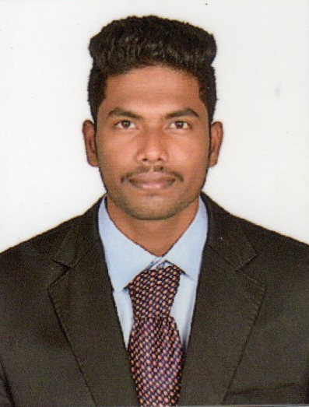
V. MATHAVAN
Mobile: +97333319017
E-mail: mathavanyuthan@gmail.com

PROFESSIONAL SYNOPSIS

Dedicated and well trained Mechanical engineer with 2 years of experience in sheet metal fabrication. Expert in mechanical design with vast experience in software such as AutoCAD, Solidworks. Have fundamental knowledge of assembly and manufacturing processes as well as diverse measuring and testing equipment. Adept at adjusting team work pace to accommodate evolving client needs and preferences.

AREAS OF EXPERTISE
- Experienced in modeling and detailing for sheet metal design
- Good hand experience in Design and Drafting
- Strong ability to use AutoCAD and SolidWorks
- Trained in the operation of CNC laser, turret and press brake
- Excellent proficiency with precision measuring instruments including calipers, tape measures and linear scales
EDUCATIONAL QUALIFICATION

EDUCATION  COURSE | NAME OF THE INSTITUTION | BOARD/ UNIVERSITY | YEAR OF  PASSING | % of Marks
B.E MECHANICAL ENGINEERING | United institute of technology , Coimbatore | Anna university | 2013-2017 | 65 %

EXPERIENCE

Organization : maniraam engineering
Duration : 2017 to 2019
Department : Sheet metal fabrication
Designation : junior mechanical engineer

Responsibilities:
- Responsible for achieving production requirements
- Design and Development of sheet metal components
- Prepare program for laser cutting
- Fabricate parts per drawing and assembled parts as required
- Planning process stages for sheet metal operation as per customer requirements
- Collaborate with team members to ensure project completion by deadline and within budget
- Test products or subassemblies for functionality or quality
- Supervise and get the work from the shop floor

PERSONAL DETAILS

Name : V. Mathavan
Fathers Name : R. Vibeeshnan
Date of Birth : 27-05-1996
Gender : male
Marital status : Single
Languages Known : English, Tamil and Hindi
Passport No : R7392022
Passport Expiry Date : 26-11-2027

DECLARATION
I hereby declare that the information furnished above is correct to the best of my knowledge.

Place:

Date: MATHAVAN V

