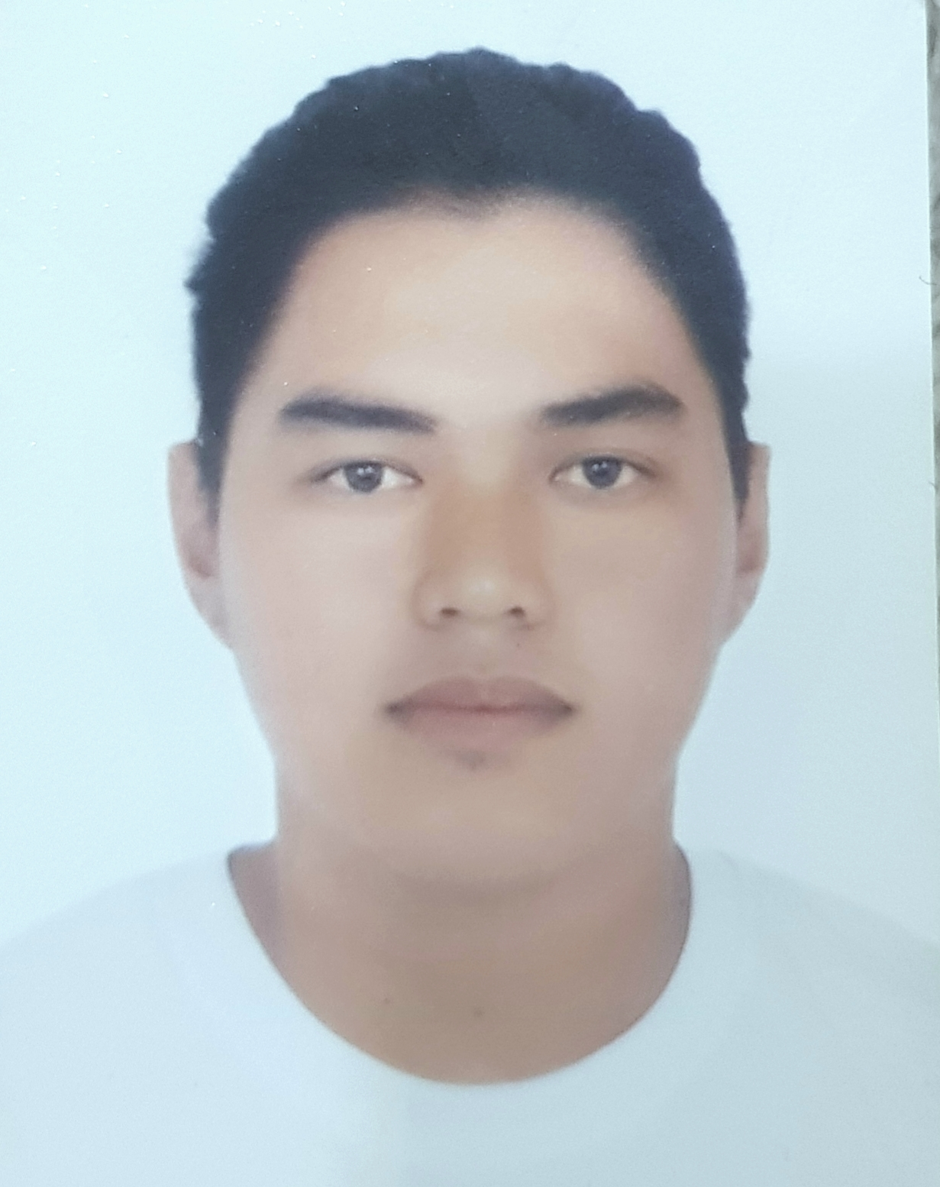
GILBERT VILLALUZ ELLOREN JR.
Flat 125, Bldg 89, Road 50
Samaheej 236, Kingdom of Bahrain
+97339040668
♦ gilvillaluz98@gmail.com

OBJECTIVE

To be able to show my knowledge and capabilities in dealing with other people for the betterment of the company.

PERSONAL DATA

Age: 24 years old
Religion: Iglesia Ni Cristo
Birthday: April 20, 1996
Birthplace: Malaybalay,Bukidnon
Citizenship: Filipino
Civil Status: Single

EDUCATION

Tertiary:
Bukidnon State University
Course: BA-Economics
Years Attended:2013-2015 (Undergraduate)

FILIPINO INSTITUTE (BAHRAIN)
Course: Barista
Vocational Course
March-April 2019

Bayanihan Institute (Bahrain)
Course: Basic Accounting
Vocational Course
March-April 2019

Secondary:
Cabadbaran National High School
Year Graduated: 2009-2013

Primary:
North Cabadbaran Central Elementary School
Year Graduated: 2003-2009

SPECIAL SKILLS

Computer Literate
Good Communication Skills

WORKING EXPERIENCE

JOLIBEE
Gaisano Malaybalay, Bukidnon
Stockman
Jan.-June2017

AL ANZAROUTI FOR FOOD INDUSTRY Co.W.L.L
Salman Industrial Al hidd, Kingdom of Bahrain
Team Leader-Machine Operator
Aug.2018-June 2020

Gilbert Elloren Jr.
Applicant

