IRSHAD MOHAMMED PM
Senior Integration/Implementation Support Software QA Engineer
 | CONTACT
Bahrain | +97335198140 | irshapm@gmail.com
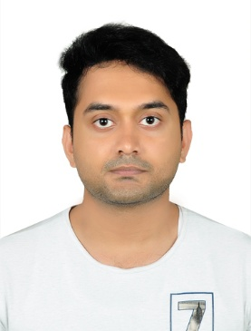  Personal Data : | Dear HR,  For the position of the title Senior Integration/Implementation Support QA Engineer at Al Moayyed Computers/International;  - 6+ years’ experience of deploy system test and leading IT QA testing team  - Have experience in delivering results and meeting customer expectations.  - Experience in Analyzing Business needs of IT systems and software.  - Always customer priority, listening to their needs and requirements to ultimately reach their satisfaction.  - Evaluates IT operations with regard to established goals and KPIs.  - Communication and co-ordination with cross functional teams as needed and required by time.  - Assessment for the need for new equipment and software  - Have BSS nodes knowledge with leading middle east clients in Telecom vertical.  - Having experience as Integration Engineer and Support Engineer for more than 5 years  - Have experience in working closely with clients and customers and delivering results + experience in working with cross functional teams  - I have in background with BSS Applications;Unix / Linux;  - Scripting knowledge with Bash or Shell;  - Experience with Oracle, PL/SQL;  - Systematic learning and researching skills;  - I have experience in delivering results & meeting customer expectations;  - I have experience in excellent planning and organizing skills.  - 6+ years of experience in working with a mobile network system  - Have Knowledge of Unix, Linux (command line)  - Have strong consultation skills  - If you are looking for a suiting resume, then you need look no further. You will see from my enclosed resume that I meet all of these qualifications and more.  - I would very much like to discuss opportunities with Aqua Care Services. To schedule an interview, please call me at +97335198140. The best time to reach me is between 9.00 AM and 3 PM, but you can leave a message at any time, and I will return your call.  - Thank you for taking the time to review my resume. I look forward to talking with you.  - Sincerely,  - IRSHAD PM
  Date of birth | 07.08.1991
  Age | 28
  Passport No | P 0989193
  Nationality | Indian
  Marital status | Married

