CHAITANYA WARRIER

Personal Details |  |  | 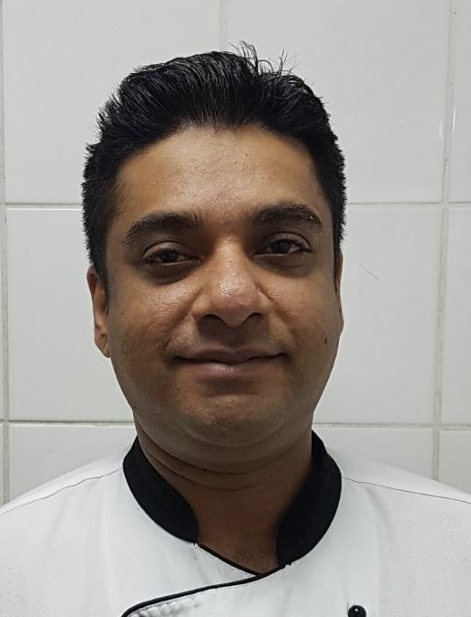
Title | CHAITANYA WARRIER
Date of Birth | 10TH November1982
Nationality | Indian
Marital Status | Separated
Children | Nil

Home Address | E-23 | Home Tel.:  Personal Mail: | +91-7558986774
(Communication) | Harishankar Puram | Home Tel.:  Personal Mail: | +973-36539682
 | Jhansi Road,Lashkar | Home Tel.:  Personal Mail: | Chaitanya82in@gmail.com
District | GWALIOR (M.P) | Home Tel.:  Personal Mail:
Zip (Post Code) | 474002 | Home Tel.:  Personal Mail:
Country | India | Home Tel.:  Personal Mail:

Height: | 175cm
Weight: | 73
Passport Number: | J6408421 | Valid Till | 26/07/2021

Educational Background & Qualifications
B.Sc Degree in Hospitality and Hotel Administration (2000-2003)From Institute of Hotel Management and Catering Technology, Bhubaneswar.

Career Achievements & Awards

- Won award in cake decoration at institute level.
- Also achieved awards in singing ,dancing ,cricket & other activities.
- Undergone a certificate course for departmental trainer conducted by O.C.L.D New Delhi.
- Conducted various food promotions at Trident Hilton, Cochin.
- Also achieved excellent award in yearly appraisal 2006-2007.
- Also achieved excellent award in yearly appraisal 2007-2008.
- Also received Star employee of the month May 2010 at Elite Resort & spa hotel.(Bahrain)
- Also received Star employee of the month December 2012 at Elite Crystal hotel.(Bahrain).

Professional strengths and special skills
- Sous chef of bakery & confectionary section.
- Take care of maintaining hygiene & cleanliness in the kitchen department.
- Taking care of entire kitchen in the absence of Executive Chef.
- Interested in chocolate work & confectionary products.
- In charge for guest comment analyses (related to kitchen) in Trident Hilton, Cochin.
- Maintaining standard recipe of all the dishes.
- Good supervisory skills.
- Expert in planning and preparation of menus items.
- Excellent in Bakery & patisserie Ala carte and banquet preparations.

industrial training
THE RESORT, MUMBAI is a reputed hotel in Mumbai. I did my 22-week of industrial exposure training in this hotel.

 | Professional Experience
 | From | November 4th 2019 |  | Establishment |  |  | Al Safir hotel & tower
 | To | Till date |  | City |  |  | Manama
 | Position | Pastry chef |  | Country |  |  | Bahrain
 | From | February 9th 2017 |  | Establishment |  |  | Elite Cristal hotel (Elite hospitality group of Hotels)
 | To | February 8th 2019 |  | City |  |  | Manama
 | Position | Sous chef |  | Country |  |  | Bahrain
 | From | March 1st 2015 |  | Establishment |  |  | Elite Cristal hotel (Elite hospitality group of Hotels)
 | To | September 10th 2016 |  | City |  |  | Manama
 | Position | Sous chef |  | Country |  |  | Bahrain
 | From | March 1st 2013 |  | Establishment |  |  | Elite Cristal hotel (Elite hospitality group of Hotels)
 | To | March 1st 2015 |  | City |  |  | Manama
 | Position | Jr. Sous chef |  | Country |  |  | Bahrain
 | From | September 26th 2011 |  |  | Establishment |  |  | Elite Cristal hotel (Elite hospitality)
 | To | February 28th 2013 |  |  | City |  |  | Manama
 | Position | CDP |  |  | Country |  |  | Bahrain
 | rom |  | February 10th 2009 |  | Establishment |  |  | Elite Resort & spa hotel(Elite hospitality  group of Hotels)
 | To |  | September 25th 2011 |  | City |  |  | Manama
 | Position |  | CDP |  | Country |  |  | Bahrain
 | From | July 1st 2007 |  | Establishment |  |  | The Trident ( part of Oberoi group of Hotels)
 | To | October 4th 2008 |  | City |  |  | Cochin
 | Position | CDP |  | Country |  |  | India
 | From | October 4th 2004 |  | Establishment |  |  | The Trident Hilton( Oberoi group of Hotels)
 | To | June 31st 2007 |  | City |  |  | Cochin
 | Position | commi |  | Country |  |  | India

Duties and responsibilites
  - Report to Executive chef.
  - Maintaining the kitchen according to the HACCP standards.
  - Trainings for junior staffs.
  - Responsible for production and presentation of menu items as per set standard
  - Developing new menu items for the approval of Executive chef
  - Supervising production planning and control
  - Assist executive chef in cost control
  - Duty allocation for the cooks
  - Maintain and monitor stock
  - Maintaining the health hygiene and safety of the cooks
  - Monitoring and maintaining the HACCP standard
  - Co-coordinating with other department for smooth operation
  - Upkeep of equipment, kitchen and store areas as per company standard
  - Help Executive Chef in training and manpower development
  - Assist Executive Chef in recruitment of cooks

I hereby declare that the details furnished above are true to the best of my knowledge and belief.

PLACE :
DATE : Chaitanya Warrier

