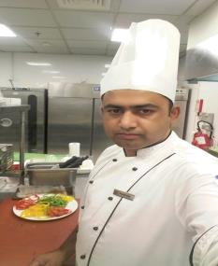
00973 35669002

Mobile n whap

Muhammadimran2432@gmail.com

Dear Chef,

I am very interested in applying for the position of commi 1.experience in the kitchens of 5 star hotels, I would be able to deliver high-quality service and great food to your guests while maintaining quality standards and maximizing profitability.

As you can note from the enclosed resume, I have a considerable expertise in:

- Cooking all kinds of food in accordance with menu and number of guests
- Ensuring the provision of high quality hospitality services
- Ensuring safe food handling procedures

As a dependable and customer-focused professional, I am looking forward for the opportunity to discuss your commi 1 position and my relevant skills in more detail.

Thank you for your time and consideration. I look forward to speaking with you soon.

Truly yours,

Muhammad imran

