CURRICULAM VITAE
ALI JAVED 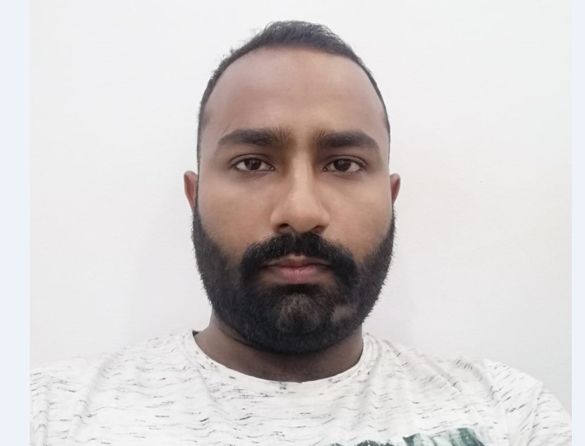
E-MAIL: ali.javed.sh.1991@gmail.com
CELL: 38051707 / 33221432
OBJECTIVES:

To reach the highest position in multinational organization in a challenging environment of Information & Advance Technologies where I could utilize my knowledge and experience.

ACADEMIC CREDENTIALS:

I.COM CSC COLLEGE Rawalpindi Board 2011
Matriculation Rawalpindi Board 2008
CERTIFICATE / DIPLOMAS:

- Six months Computer professional Diploma in Information Technology from
Micro Computer Professionals CHAKWAL
- English language course on proficiency level from
N.U.M.L ISLAMABAD

PROFESSIONAL EXPERIENCE:

- Worked as a “Computer Operator” in Shah Faisal Shaheed International Tours Operators From 28Aug2004 to 28Jun2006.
- Worked in Meat Mart (Pvt.) L.T.D as a “Computer Operator” from 15 Nov,2006 to 31st Nov,2007.
SKILLS / ABILITIES:

I have several years experience working with computer and internet and I am competent in the following.
- Ms Office (Word, Excel, Power Point, Access, Outlook)
- Proficient in use of Windows 95 to Windows Vista, Internet & E-Mail
- Effectively work in Groups & Teams

Extra curricular activities:

- Poetry
- Reading Books
- Playing Cricket & Snooker

PERSONAL INFORMATION:

NAME : ALI JAVED
FATHER’S NAME : JAVED AKHTAR
Date of Birth : 08-05-1991
PASSPORT : DE8673302
NATIONALITY : PAKISTANI
RELIGION : ISLAM
MARTIAL STATUS: SINGLE
Driving License : Valid License ISLAMABAD / Pakistan
LANGUAGES : English : Speaking – Writing – Reading
Urdu : Speaking – Writing – Reading
Arabic : Little Speaking
Punjabi : Speaking

Reference upon request.

