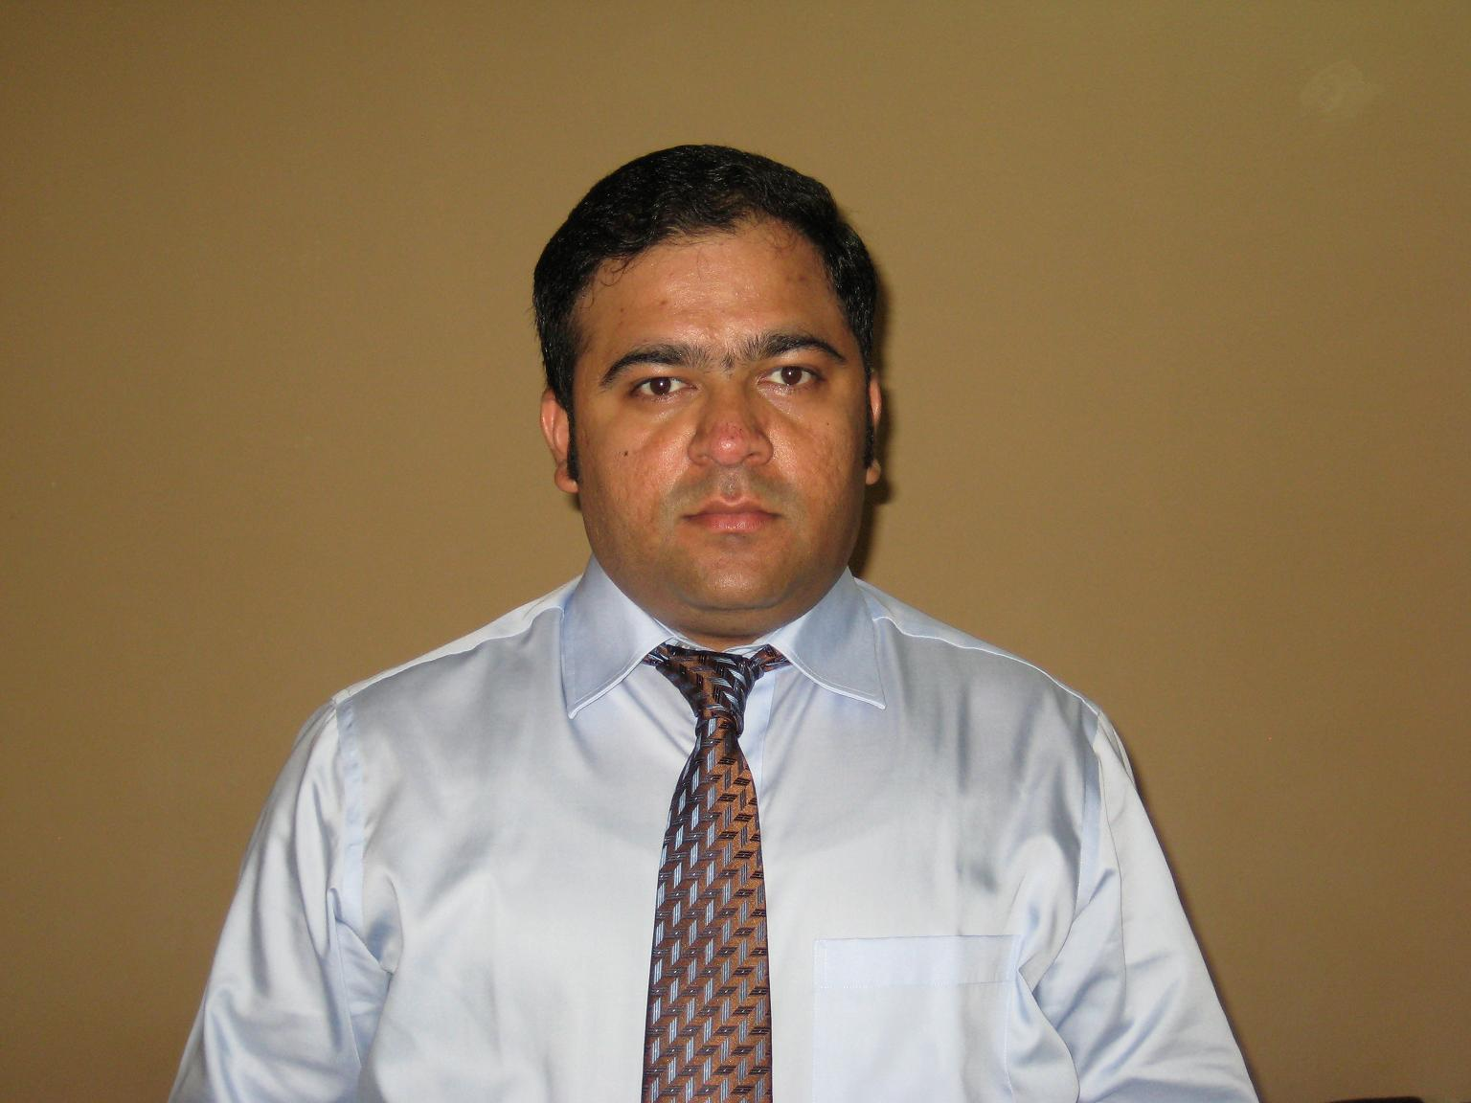

Vikram Kadam
Flat F02, Capitol Building, Bur Dubai,
Mobile: 00971 555864229
Email Id : vikram_kadam7@yahoo.com

- Over 18 years of comprehensive experience in Sales-Distribution and Business Development, Retail Store operations, Inventory, Category Management, Man Management, Staff Training / Counselling, Customer Service with diverse industries.
- Expert professional in business development, planning and executing business strategies, experienced in developing new market channels and building strong relationships with sales team, customers and industry leaders.
- Superb understanding of business sense and strategies.
- Holding valid Bahrain and UAE driving license.
- Currently Designated as a Key Account Manager with Wild Republic FZE., Sharjah, UAE

Desired to join a fast paced growing firm that offers a constructive workplace to develop brand strategies, initiate strategic alliances, promote new products, and interaction with new clients in order to develop sustained business for the organization

Employment Details

Wild Republic FZE. Sharjah, United Arab Emirates
Since Dec 2019 – Till Date

Key Account Manager.

Significant Highlight:

- Handling Retail and Wholesale Distributorship of Toys Business.
- Handling Key Accounts in Hyper Market & Speciality Retail Stores segments, such as Carrefour, Lulu, Hamleys, Virgin, Toys r us and Toys Store.
- Taken up a special challenge of improving company's presence in GCC market.

Rosha Trading L.L.C., Dubai, United Arab Emirates
(3 Years) Since Oct 2016 – Till Sep 2019

Sales Key Account Manager.

Significant Highlight:

- Handled Retail and Wholesale Distributorship of Toys Business.
- Handled Key Accounts in Hyper Market & Speciality Retail Stores segments, such as Carrefour, Lulu, Hamleys, Virgin, Toys r us and Toys Store.
- Was responsible for Brand management, Revenue management, Retail Distribution and Sales Operation.
- Worked closely with Senior buyer and Principles to finalize the new lines as well as their launch plans.
- Was also responsible for placing the orders and dealing with shippers to ensure smooth and timely arrival of the products.

Viva Entertainment, Dubai, UAE. 1 Year & 1 Month) Since Sep 2015 – Sep 2016

Key Account Manager for Retail & Wholesale Distribution (Toys business).

Significant Highlight:

- Handled & Developed Toys business in hyper market segment.
- Was responsible for Brand management, Revenue management, Retail Distribution and Smooth Sales Operation.
- Was reporting to Business development manager and Chairman.
- Developed – implemented the market strategies & promotional activities to achieve the Sales Budget with agreed margins.
- Handled a team of Two Sales Executives and Three Merchandisers.

Ashrafs W.L.L., Subsidiary of Y. K. Almoayyed and Sons, Bahrain
(1 Year & 9 Months) Since Dec 2013 – Aug 2015

Sales Supervisor for Agency and Distribution.

Significant Highlight:

- Developed & handled exclusive distributorship of Emjoi & Sencor brands in Kitchen Appliances.
- Solely developed entire market of Bahrain, Such as Hypermarkets, Power retailers & Dealers.
- Was responsible for Brand management, Revenue management, Ordering & Distribution.
- Used to work closely with Distribution Sales Manager, General Manager & Principles.
- Developed & implemented market strategies & promotional activities to achieve the Sales Budget with agreed margins.

Emax Electronics, Al Rashid Group WLL, Bahrain
(A Division of Landmark Retail Ltd) (4 Years) Since Dec 2009 – Nov 2013

Assistant Retail Store Manager

Significant Highlight:
- Started and worked as a Department Manager for one year, later on got promoted.
- Handled 20,000 Square feet Retail Shop of Emax Electronics, Muharraq.
- Supervised and Managed 27 individuals in Oriented retail environment.
- Was responsible for overseeing all aspects of Retail Store Operations such as Following Plano gram, Merchandising, Promotional Activities, Customer Service, Inventory Management and Cash Handling.
- Given Training, Recruited and hired Retail store employees, Administered payroll and addressed HR inquiries.
- Used to maintain reports on Daily Sales, Shop Inspections, Safety and Security standards.
- Was Responsible for Merchandising and positioning products throughout the store to maximize sales and profits,
- Used to drive the sales team to achieve the monthly and yearly Sales Budget with agreed front-end margins.
- Was responsible to ensure that overall SOP and Company Guidelines are getting followed at any given time.

Jacky's Electronics, Dubai, UAE (3 Years) since Aug 2006 – Sept 2009

Assistant Duty Manager.

Significant Highlights:
- Started & worked as a Section Head for over 18 months, later on got promoted.
- Used to manage Audio - Video & Appliances Department.
- Handled a team of 15 personnel (2 Team Leaders, 6 Sales Associates, 7 Brand Promoters)
- Used to drive the sales team to achieve the monthly and yearly Sales Budget with agreed front end margins.
- Was responsible to maintain Plano gram, Category Management and Inventory Management.
- Used to maintain Sales report on Daily, Weekly & Monthly basis for review meeting with Area Manager.

Planet M Retail, the Times of India Group, Mumbai, India (2 Years) since June 2004 – July 2006

Section Head.

Significant Highlights:
- Used to manage Section of Home Entertainment.
- Was responsible to follow the SOP of that particular department.

Titan Industries Ltd. Mumbai, India. (3 Years) Since April 2001 – May 2004

Counter Sales Executive.

Significant Highlights
- Used to handle one of its Kiosk Outlet in Planet M & Pantaloons.

Education Details

- B.COM (Hon’s) from Mumbai University, 2004.
- Higher Secondary School Certificate in Commerce from RKT College, 1998 (Mumbai Board).
- Secondary School Certificate from National School, 1996 (Mumbai Board).

Personal Details

Date of Birth : 7th April, 1981.
Nationality : Indian
Visa Status : UAE Employment Visa
Languages known : English, Arabic & Hindi.
Marital Status : Married

Place:
Date: Signature :

