RESUME
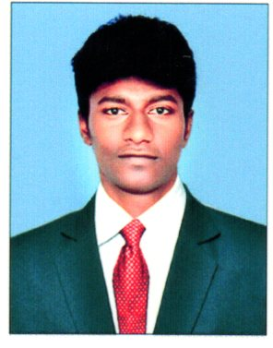
Name: D.RAM PRAKASH
E-Mail: rambasha1996@gmail.com
Contact No.:+973 35431372

CAREER OBJECTIVE:
- To be a successful professional in a Globally Respected Hotel and to achieve the objectives of the hotel with honesty and fairness and to Continuously Upgrade My Knowledge and skills.
- I want to prove my skill & talent in working, which \makes use of all my potential. I will always deliver my best in job given to me.

EDUCATIONAL QUALIFICATION:
Qualification | College | University/  Board | Year of Passing | Percentage
B.SC | |Cenneys institute of hotel management, Salem | Periyar University | 2014-2017 | 65% Above
HSC | John Dewey Matric Higher sec school, Panruti | State Board | 2014 | 73%
SSLC | John Dewey Matric Higher sec school, Panruti | State Board | 2012 | 75%

ACHIVEMENTS:
- I have successfully organized many function in my college and done lots of works in the production department.
- College workshops certificates with lot of involvement in it.
- I have involved in sweet work shop and learned some sweet recipes.
- And I have got some inter college Workshop certificate.

SOFT SKILL:
- Creativity Thinker
- Innovative cooking
- Positive attitude
- Leadership
- Plate Decorating
- Hard Worker

LANGUAGE KNOWN:
- English - Good in writing and moderate in spoken.
- Tamil - Fluent in writing and also in speech.
- Hindi – fluent in speaking

INTERSHIP:

- As a FOOD &BEVERAGE Trainee Waiter in Cenney’s gateway 3 STAR in Salem.
- As a FOOD &BEVERAGE Trainee bartender in the JW Marriott, Chandigarh.
- Worked as a waiter in SHERATON HOTEL at Bahrain
- Worked as a waiter in PARS INTERNATIONAL HOTEL at juffair,Bahrain from August 9TH 2018
- Promoted as a FOOD AND BEVERAGE Bartender in PARS INTERNAIONAL HOTEL at juffair,Bahrain effective from the month of October 23th 2018 to till date

AREA OF INTREST:
- FOOD&BEVERAGE SERVICE

HOBBIES:

- Listing song
- Dancing
- Sports player

PERSONAL INFORMATION:
Name | Ram Prakash. D
Father’s Name | Dharuma Raj R
Date of Birth | 22.10.1996
Gender | Male
Nationality | Indian
Religion | Hindu
Marital Status | Single
Address | 4/102, Patta Ramasamy Nagar,  Thiruvathigai (PO)  Panruti (TK)  Cuddalore (DT)

REFERENCE:

- Mr.Uday Mahar Singh
General Manager
Pars international hotel
- Mr.Manohar Karuthedath
Food and beverage manager
Pars international hotel
- Mr.Manoj G Nair
Asst.food and beverage manager
Pars international hotel

DECLARATION:

I hereby declare that the above furnished details are true to the best of my knowledge and belief.

Place: chennai
(Ram Prakash. D)

