Curriculum Vitae

- Personal Details
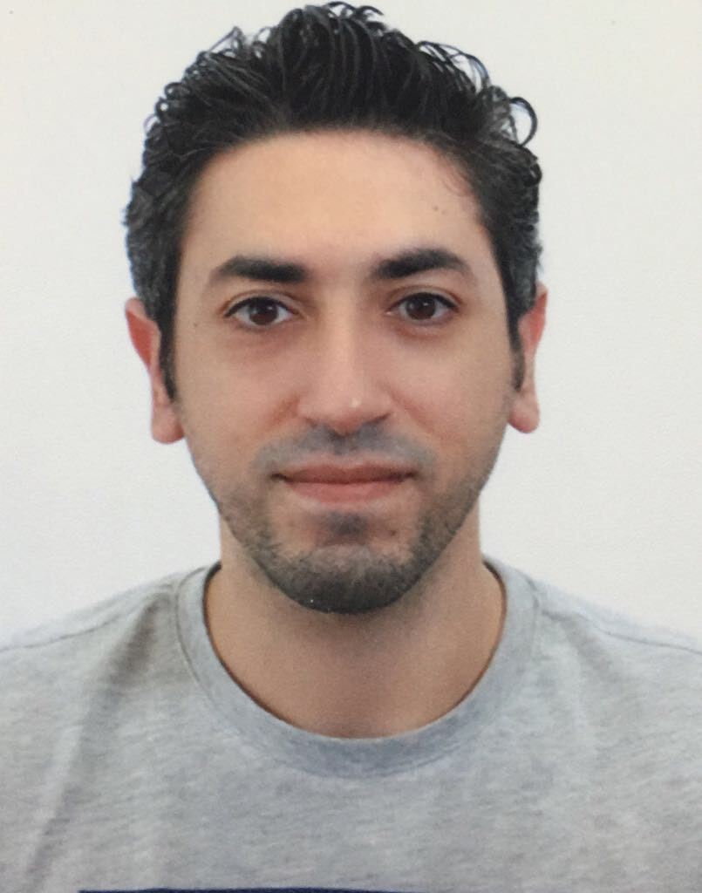
Name: Mohammed Mohsen Saber ELhadary
Nationality: Egyptian
Profession: Accounting - Banking
Date & Place of Birth: 24th March 1989 – Cairo
Present address: Building 811, Road 833, Block 408, Sanbis-Manama
CPR: 890358036
Language: Arabic - Native
English - Excellent
Marital Status: Married
Contacts: Mobile: 00973 39380863 - 00973 33494222
Email: mohamed.elhadary@hotmail.com

- Objective

Egyptian living in Kingdom of Bahrain, Experienced, detail-oriented accountant seeks for a position where I can extensive experience that will be further developed and utilized. That would render my knowledge, experience, and expertise in all aspects starting from organizational management. To build upon existing corporate finance skills in both transaction execution and analytics, leading to increased responsibilities.

- Educational Qualifications

▪ Egyptian Banking Institute (2011):

- Development & Bank Account
- Business Awareness
- Retail Banking
- Customer Service
- Credit Card
- Foreign Trade Operation
- Communication Skills
- SME
- Commercial Paper

▪ The Modern Academy Maadi University in Egypt - Cairo (2005-2009)
- Bachelor degree in Accounting
Grade: Good
- Graduation Project: Internal Control and Fraud
Grade: Excellent

▪ Secondary School from Atef Brakat Language School
Cairo, Egypt (2002-2005)

 Key Qualifications & Computer skills

▪ Hard worker, Team player, & fast learner
▪ Excellent leadership skills
▪ Excellent communication skills
▪ Ability to adapt the change with different culture and different people
▪ Have a very good relations in different fields: (Tourism, Industry, Banks…ETC.)
▪ Microsoft Office

 Experience:

Working at Kuwaiti Manger Contracting (KMC):
January 2017 till date.
- Type of work: Accounting
Worked at the International Hospital of Bahrain:
September 2016 - December 2016
Type of work: Patient Relations
Worked at The United Bank of Egypt at Fraud Department:

August 2011 - August 2016.

- Type of work: Fraud Investigation
- Description: Risk Management

Worked at Holiday Inn Hotel as Front Office Clerk:
January 2010 - June 2011.
- Type of work: Front Office Clerk

