EDUCATION
AWARDS & RECOGNITION
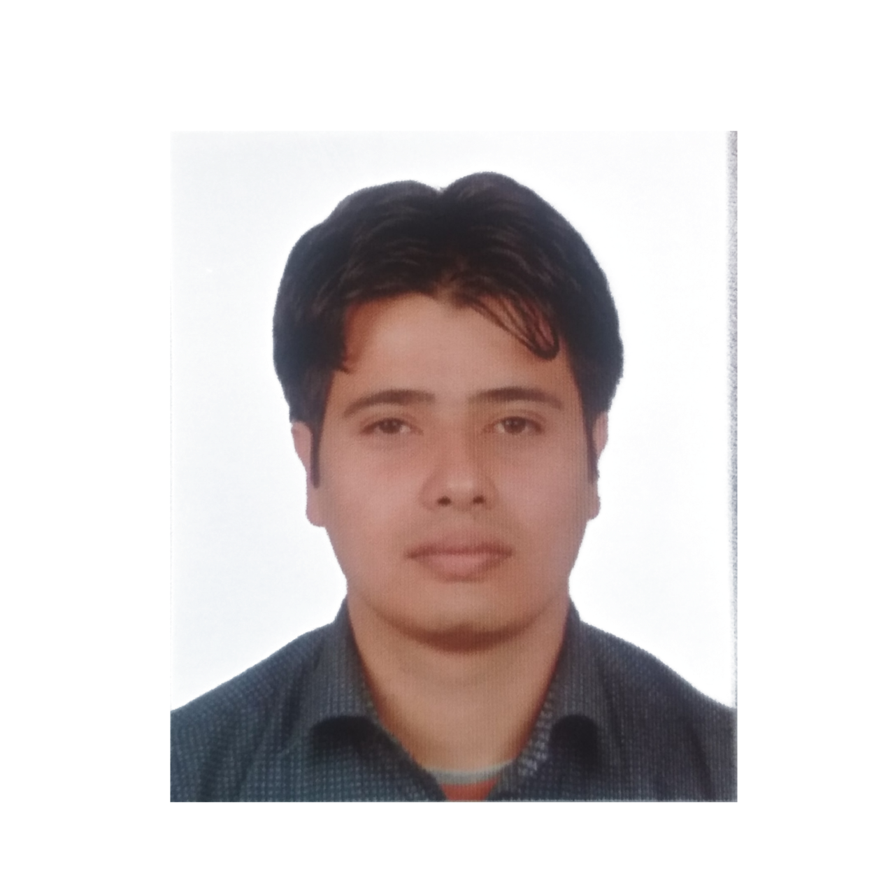

TRIBHUVAN UNIVERSITY 07/2005~10/2008
- Bachelor of Business Studies
Public Youth College, Kathmandu, Nepal.
HIGHER SECONDERY EDUCATION BOARD 06/2003~05/2005
- 10+2 Intermediate.
Shree Kalika Higher Secondary School, Tanahun.
SCHOOL LEAVING CERTIFICATE 2003
- SLC
Shree Rastriya Secondery School, Tanahun.

Binod KC

Admin Assistant

EXPERIENCE
INFORMATION

03.07.1987
+977-9806694560
kcpurkote@gmail.com
Tanahun, Nepal.

China Petroleum Engineering & Construction, Algeria Administrator 11/2017~10/2018
- Perform clerical duties such as preparing documents, memos, answering phone calls, emails & correspondence etc. managing appointments, meetings & seminars, maintain user friendly filing system, purchasing office supplies & tracking its distribution, oversee the maintenance of office facilities & office equipment,
Sinopec Engineering Saudi Co. Ltd., Saudi Arabia Admin Officer 11/2015~5/2017
- Organize & schedule meetings, produce correspondence, memos, letters etc. maintain effective filing system, order office supplies, book travels, generate reports, prepare and monitor invoices.
Snamprogetti Saudi Arabia a Company of Saipem QA/QC Technical Clerk 12/2013~07/2015
- Tracking Hydro test Packages, scan & archive in Test Package center.
YanbuSteel Company, Saudi Arabia Administrator 05/2011~02/2012
- Coordinate & oversee all office activities, travel arrangements, prepare notice & memos, coordinate with administrative teams, arrange meeting, handle phone calls & correspondence, manage filing system.

SKILLS

- Languages:
English, Hindi, Nepalese and basic Arabic.
- Computer:
MS Windows
MS Word
MS Excel
MS Powerpoint
TALLY
Photoshop
Email & Internet
- Other Skills:
Team Player, Leadership, Good Communication, Competency, Proficient &
Time Management

Model Worker of the Year 2016
Received the Award for Model Worker of the year 2016 awarded in Sinopec Engineering Group Head Office Tianjin, China.

