CURRICULUM VITAE

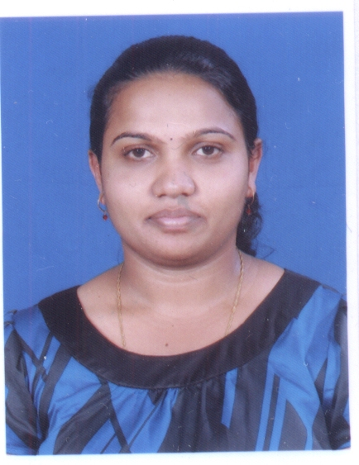

Avitha Cynthia Rodrigues
Flat No 62 , Daytona Building
Road No 2421, Block No 324
Manama Bahrain
Mob: 00973 38140917
E-mail- avitha_rodrigues@yahoo.com

OBJECTIVE:

Looking for a challenging Admin Assistant position with esteemed organization, where my skills and experience will greatly enhance for organizational success and my own personal growth.

Professional Experience

Park Regis Lotus Hotel, Bahrain

Working as HR Executive – Human Resource Dept.

From 01st April 2018 to till date

Job Responsibilities:
- Knowledge of LMRA, Gosi and Bahrain law
- Answering employee questions
- Processing incoming mail
- Providing customer service to organization employees
- Maintaining computer system by updating and entering data
- Setting appointments and arranging meetings
- Maintaining calendars of HR management team
- Compiling reports and spreadsheets and preparing spreadsheets
- Participating in recruitment efforts
- Posting job ads and organizing resumes and job applications
- Scheduling job interviews and assisting in interview process
- Preparing new employee files
- Orienting new employees to the organization (setting up a designated log-in, workstation, email address, etc.)
- Serving as a point person for all new employee questions
Payroll and Benefits Administration
- Processing payroll, which includes ensuring vacation and sick time are tracked in the system
- Answering payroll questions
- Facilitating resolutions to any payroll errors
- Participating in benefits tasks, such as claim resolutions, reconciling benefits statements, and approving invoices for payment
Record Maintenance
- Maintaining current HR files and databases
- Updating and maintaining employee benefits, employment status, and similar records
- Maintaining records related to grievances, performance reviews, and disciplinary actions
- Performing file audits to ensure that all required employee documentation is collected and maintained
- Performing payroll/benefit-related reconciliations
- Performing payroll and benefits audits and recommending any correction action
- Completing termination paperwork and assisting with exist interviews

Working as Sales Coordinator / Reservations

From 14th May, 2015 to 31st March 2018

Job Responsibilities:
- Prospecting - Personal selling is a more assertive promotional strategy that usually coincides with a hotel's advertising and public relations campaigns.
- Sales Presentations: Once a prospect expresses interest in holding an event and shares his buying conditions, the coordinator moves into sales mode.

Event Coordination: Customer service to the clients.

- Reservations: Room bookings, banquet bookings, group booking, online booking.

- Follow up: with rooming list, action plan on groups, payments, preparing corporate agreements.

- Preparing Minutes of Meeting: Attending the meeting with team and preparing the minutes of meeting.

Ramee Groups of Hotels and Restaurants, Bahrain
Working as Front Desk Officer & secretary to GM in Windsor Tower Hotel
From 14th April, 2013 to 12th May, 2015
Job Responsibilities:
- Dealing with the Guests, taking bookings, assigning rooms.
- Shattering of the guest, setting wake up calls on guest request.
- Cashiering
- Preparing Receipts, Invoice and payment vouchers
- Answering the phone calls
- Providing services to the guest on their requirements
- Using a variety of software packages, such as Microsoft Word, Outlook, Powerpoint, Excel, Access, etc., to produce correspondence and documents and maintain presentations, records, spreadsheets and databases;
- Devising and maintaining office systems;
- Booking rooms and conference facilities;
Mphasis
Place of Work : Mphasis an HP Company, Mangalore, India.
Duration : June 2012 to January 2013
Position : Asst. Accountant.

Job Responsibilities:
.
- Maintained book keeping and cash flows
- Scrutinized debtors and creditors on weekly basis and follow up for the same
- Worked on accounting package Tally
- Preparing Invoice Vouchers, Receipts, Payments Vouchers
- Preparing Statements of Accounts
- Credit Controller, Payables & Petty cash management
- Handled daily data entries, Income/sales reports, sales receipts and bank account transactions
- Coded payables/receivables produced invoices and assisted in preparing monthly financial reports.
- Performed various routine adjustments to company documentations, records and logs.
- Double-checked accounting reports, verified invoices and various documents for accuracy.
- Balanced entries, organized documents, debits and credits.
- Prepared supporting documentation for auditing whenever customers or auditors required.
- Compile completed tax returns using manual punch binding system.
- Securities, long-term debt and interest calculations
- Reconciled bank accounts and Balance Sheet accounts on a monthly basis.
- Maintain General Ledgers.
- Responsible for documentation and records of financial information
- Prepare the production's accounts and process payments
Educational Qualification

- Bachelor in Business Management, (BBM) Manglore University, India
- Diploma in Secretarial Practice Karnataka Secondary Educational Board, India

Professional Qualification

- Diploma in Computer Application (MS- Office, Power point, Tally7, Excel, Coreldraw, Outlook)
- Book Keeping and Accountancy (Govt. Certification)
- English Typing Senior Grade (45 wds/min) (Govt. Certification)
- Office Practice and Procedure (Govt. Certification)
- ‘Management Trainee’ Certificate (BIG DAYS in Big Bazaar, Karnataka, India)

Personal Profile.

- Religion : Christian
- Nationality: Indian
- Date of Birth : 10-02-1990
- Marital Status : Married
- Passport No : K8374055
- Date of Issue : 11.Dec.2012
- Date Of Expiry : 10.Dec .2022
- Languages known : English, Hindi, Konkani, Kannada
DECLARATION
I hereby declare that all the statements given are true to the best of my knowledge and belief.

Place:Manama, Bahrain Avitha Cynthia Rodrigues

