  M/V WORLD DREAM  GALLEY DEPARTMENT  CREW PROFILE | 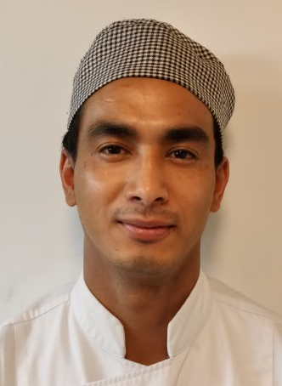

NAME (Surname, First Name, Middle Name): |  |  |  |  |  |  | SAP NUMBER:
shrestha, bhushan |  |  |  |  |  |  | 90005090
ORIGINAL SIGN ON DATE: |  | POSITION: |  |  |  | DEPARTMENT & SECTION:
18 Dec 2009 |  | 2nd WOK I |  |  |  | Hotel/Galley
CONTACT ADDRESS:
Hadiyaun-B, Kathmandu, Nepal
EMAIL ADDRESS: |  |  | TELEPHONE NUMBER: |  | BIRTHDATE:
badbasanta@gmail.com |  |  | +97774441760 |  | 20/05/1988
COURSE/DEGREE EARNED : |  |  |  | PERIOD COVERED: | NAME OF SCHOOL/COLLEGE/UNIVERSITY:
Intermediate |  |  |  | 2006-2008 | Brilliant Educational High School
NATIONALITY: | LANGUAGE(S) SPOKEN: |  |  |  |  |  | CIVIL STATUS:
Nepalese | English, Nepali |  |  |  |  |  | Single

JOB EXPERIENCE:
DATE (From – To) | POSITION | JOB DESCRIPTION | COMPANY
2011-2012 | 3rd Cook | Buffet Operation | Star Cruises (SPC)
2012-2013 | 3rd Cook | Dimsum | Star Cruises (SPC)
2013- Present | 2nd Cook | Chinese Cuisine | Star Cruises (SPC)

PERSONALITY:
Kind, friendly, and focused on his job.

JOB ATTITUDE:
Hardworking, can work in different section.
JOB PERFORMANCE:
Flexible all the time, can do his duties very well.

LEADERSHIP:
Need more knowledge and experience in galley.

Evaluated by: Pungky Asmara- Sous Chef/ DDR Lower Western

