ODAI ABBAS HASAN MOHAMED
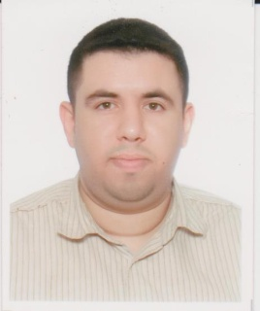
House 72, Road 87, Al-Daih 412
Kingdom of Bahrain

Tel: +973 66971112

Email: odaimhd@gmail.com

PERSONAL INFORMATION

- Marital Status: Married
- Nationality: Bahraini
- DOB: December 18th, 1981
- Languages: Arabic & English

OBJECTIVE

To apply for

Customs Clearance Agent

KEY SKILLS

- Years of experience in clearing goods (Imports & Exports).
- Expert in using OFOQ Bahrain Program.
- Professional, Friendly, and Courteous in Building a strong relationship with clients.
- Problem solving with the ability in providing effective solutions and respond to complaints professionally.
- Apply services to expectations.
- Flexibility to adapt with the needs and changing circumstances and to work without supervision.
- Time management.
- Initiative and Proactive.
- Able to work with Microsoft Office.

EDUCATION

1999 Naim Secondary Boys School
Science Stream

WORK EXPERIENCE

June 2014 – October 2019
Gulf Agency Company

Senior Customs Broker

September 2012 – May 2014
Orient Express Logistics

Customs Broker

September 2011 – September 2012
Ibn Al-Nafees Hospital

Receptionist

July 2009 – August 2011
Awal Express

Customs Broker

December 2006 – February 2009
Awal Dairy Company

Customs Broker

September 2004 – November 2006
International Agencies Company

Customs Broker

Duties and Responsibilities:

- Managing the responsibility of customs clearance of inbound and outbound goods.
- Follow up on customs procedures and ensure that the clearance process runs smoothly.
- Assist the manager in managing the team's work, following up the clearance team, and providing them with assistance when needed.
- Monitor customs and regulatory laws and ensure that they are applied and complied with.
- Solve customs clearance problems and ensure the best solutions are found to complete the clearance process easily.
- Give priority to clearance as per the priorities of logistics services, and organize them according to their importance.
- Ensure clearance of goods on time to meet required deadlines.
- Ensure processes and methodologies are followed to accomplish work perfectly.
- Follow up on e-mail, respond to incoming mail, and update those concerned immediately with clearance status.
- Issuing a daily report of all completed and pending works.
- Ensure work is done to expectations.
- Documenting and filling documents and other related issues.

INTERESTS

- Reading.
- Surfing the internet.
- Computer Applications.
- Travelling.

