Aswin Fernando.E. 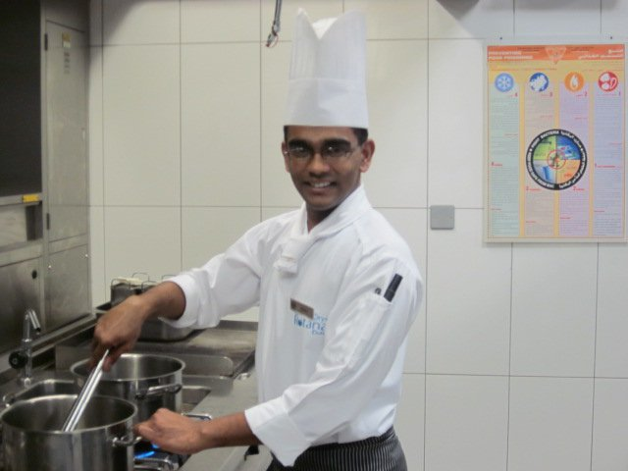

Tel:+973 39582133, Email: fdoaswin39@yahoo.com, aswinfernando7@gmail.com

Experienced cook actively seeking a position in the culinary field which will offer me to continue to learn and develop my skills and help me realize my ultimate goal of becoming an executive chef.
Challenging Summary of Qualifications

- 14 years of experience in food production of specialized in( Asian ,continental, Arabic,Mexican,Mediterranean) salads,grills,hot food and Japanese Sushi Making.
- Experienced Chef with a demonstrated history of working in the hospitality industry. Skilled in Catering, Food &Beverage, Hospitality Management, Hotel Management, and Hospitality Industry. Strong operations professional with aDiplamo in Hotel Mgt focused in Hospitality Administration/Management
- Extensive knowledge in all areas of restaurant.
- Proven ability to work under pressure without sacrificing quality.
- Excellent presentation skills
- Fast Learner and worker.
- Good coordinator and team worker.
- Ability to supervise the team and perform quality/quantity checks.

Professional Experience
AL SALAM ROTANA ,NORTH SUDAN apr 2015 –sep 2019

- Worked as a Chef Tournant in main kitchen.
- The Supervisor schedules and coordinates the work of chef’s, cooks, and other kitchen employees to ensure that food preparation is economical, technically correct and within the given budget
- To develops recipes and techniques for food preparation and presentation which help to assure consistently high quality
- To supervise cooks and directly supervises chefs cooking and work
- To develops and suggests recipes based on specific requirements (Food & Beverage brands, kitchenware, equipment, cuisine, etc.)
- Taking responsible for all inventory and maintenance of all onscreen and back kitchen utilities, including, electronic and non-electronic items, kitchenware, etc.
- To ensures that high standards of hygiene, cleanliness and safety are always maintained throughout all kitchen areas
- To Supervisor& evaluates food products to ensure that company quality standards are consistently attained
- To Supervisor establishes, controls and minimize food waste and theft
- To controle the approves the requisition and purchase of products and other necessary food supplies
- To moniter implements measures to minimize food costs; exercises portion control for all items served and works with their reporting manager to establish efficient prices
- The Sous Chef Supervisor ensures proper staffing, maximum productivity and exceptional quality standards

        - MILLENNIUM,DOHA,QATAR oct 2014-mar 2015
- Worked as a chef –de-parte in main kitchen
- Responsible for the proper efficiency and profitable functioning of the assigned kitchen. Supervises the work of Demi Chefs and Commis and Pantry personal, remaining fair at all times.
- The ability to follow proper payroll and uniform procedures.
- The ability to demonstrate a good sense of aesthetics, decorating and producing product within the quality standard guidelines as established.
- The ability to work closely with standard recipes and presentations in order to maintain quality standards and consistency of product.
- The ability to assist in production and maintenance of par stocks of Vegetables, Dry Store, etc. as per hotel standards.
- The ability to assist in the training of subordinates, particularly sensitive to their development and training process.
- The ability to assume the responsibilities of all kitchen operations
- The ability to work neatly and cleanly, keeping work areas and walk-ins in accordance with sanitary standards.
- The ability to keep waste to a minimum.
- The ability to maintain a cooperative working relationship with fellow employees.
- The ability to respond properly in any hotel emergency or safety situation.
- The ability to perform other tasks or projects as assigned by hotel management and staff.

AL SALAM ROTANA,NORTH SUDAN dec 2012 –june2014

- Worked as a chef –de-parte in main kitchen
- Which includes banquet weddings , set menus , Restraunt theme buffets.
- Taking responsibilities in absence of sou-chef ,under the knowledge of executive sou-chef.
- Taking responsibilities in ordering food indent for daily operation and for banquets.
- Taking responsibility for training the junior staff for good hygine practice and giving the on job training (OJT)as per the SOPs.

ORYX ROTANA, Doha, Qatar june 2010 – june 2012

- Worked in hot kitchen live buffet including all Theam nights.
- Worked in jazz bar (finedining & tapas kitchen, asian style)
- Worked in cold kitchen & live cooking hot kitchen (choice international multicusin restaurant)as demi-chef

Crowne Plaza, Bahrain Sep 2007 - May 2010

- Worked for Gardmanger as a commie -1.
- Managing the food ordering process for gardmanger
- Prepared and cooked meals for campers and staff.
- Oversaw kitchen clean up through/with Assistant Cook and Food Service Staff.
- Ensured kitchen areas are constantly clean - ranges, cooler, freezer, mixer, slicker, floor, dish washing, pots & pans, dining room, garbage, recyclables, etc.
- Assisted hot kitchen whenever possible.
- Took additional responsibility of Live kitchen during seasonal times
Learned the art of Japanese SUSHI production

MohammedJalal Catering, Bahrain Jan 2007 – Aug 2007

- Worked as Catering Assistant for Industrial Catering Service.
- Responsible in the preparation of high calorie cyclic menu for 700 employees.
- Oversaw food inventory by monitoring proper food temperature, rotating and storing food properly.
- Guided Food Service Staff and at times did the service myself.
- Helped at developing menus, maintaining food inventory, food preparation and storage, large scale cooking

Penny’s Restaurant, Bahrain Mar 2006 – Dec 2006

- Worked as Chef & In charge.
- Prepared all restaurant menu items: sandwiches, wraps, salads, pasta, etc.
- Performed inventory and order controle.
- Created, planned and cooked all daily specials.
- Created custom designed menus for private clients and for special occasions and implemented a catering system.

Taj Coromandal, India June 2005 – Jan 2006

- Worked as Trainee Chef De Parte
- Responsible for allocating party menu sheets.
- Supervised and organized kitchen helpers
- Received training for food testing process.

Taj Garden Retreat, India Oct 2003 – Feb 2004

- Worked as Trainee as part of Industrial Exposure Training.
- Took responsibilities in all major departments like House keeping, Front Office, Food & Beverage Service and Food & Beverage Production.
- Specialized in Food & Beverage Production.
- Produced various typical south Indian dishes.

Education qualification

- Diploma Holder in Hotel Management and Catering Technology from Shevaroy’s College of Hotel Management and Catering Technology under the university of American Hotel and Lodging Association affiliated by the American Government.

Professional Training & Achivements certificates

- Completed certificate course in Food Hygiene, H.A.C.C.P & Fire Safety through Royal Institute of Health & Hygiene, London.(stage 1)

- Done a certificate course on DESTINATION LEADERSHIP PROGRAME conducted by(Al Salam Rotana,Sudan)

- Undergone training by Directorate General of Shipping,Government of India,Mumbai (STCW) (INDoS) no 12HL1889

- Fire prevention and Fire Fighting(stcw)

- Proficiency In Elementary First Aid(stcw)

- Proficiency In Survival Techniques(stcw)

- Certificate Of Profiency In Personal Safety And Social Responsibilities(stcw)

- Completed certificate course in Food Hygiene, H.A.C.C.P (intermediate)level 3

- Worked in task force team at Abu-Dhabi Crowne Plaza (Yas Island).
- Award winning as a employ of the month for January 2012(ORYX ROTANA DOHA)
- Award winning Rotana Life Card for Ethical on February 2012(ORYX ROTANA DOHA)
- Award winning for Rotana best Hygiene practices in2013( Al Salam Rotana ,Sudan)
- Award winning for best employe of the month of December(Al Salam Rotana,Sudan)
- Award winning for Rotana best Hygiene practices in2015( Al Salam Rotana ,Sudan)

Date: (AswinFernando)

