28th July 2019

Dear Mr. / Mrs. General Manager,
Dear Head of Recruitment,
Dear Mr. / Mrs. Human Resources Manager,

Good day,

I am Bahraini National, holding 16 years of experience in the in Human Capital/Human Resources Domain.

I am currently seeking placement with your esteemed firm at a managerial level where I can contribute to the growth by utilising my experience and training gained throughout the years.

I hope to hear from you soon for an interview, whereby I can explain more about my career profile.

Respectfully yours,

Fahad Al Abbasi

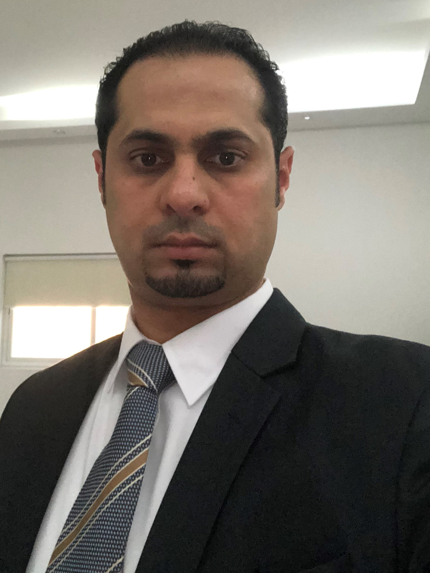 Fahad Abdul Aziz Abdulla Al Abbasi

Objective ___

To acquire a managerial position in the field of Human Resources, whereby I can contribute to the business structure, organisation and growth.

Personnel Details ___

Nationality: Bahraini National, born on 22nd of Jan, 1978
ID Number: 780105419
Mobile: 39992221
Email: fahadalabbasi@gmail.com
City: Isa Town
Country: Kingdom of Bahrain
Marital Status: Divorced
Mobile: +973 39992221

Experience ___

Bahrain Flour Mills Co. (June 2014 – Aug 2019) www.bfm.bh Bahrain

Human Capital Manager (Head of Human Capital)

- New Grading Structure
- New Organization Chart
- New Manual
- New Policies & Procedures
- New Branding
- KPI
- Productivity
- Recruitment
- Appraisals
- Training Plan
- Succession Plan
- Manpower Plan
- Redundancy and Turn Over Plan
- Health & Safety
- Security
- Pest Control
- Cleaning
- Lawyer
- Bahrain Labour Law
- SIO
- Tamkeen

Inovest (Aug 2003 – May 2014) www.inovest.bh Bahrain

Human Capital Manager

In charge of:

- Planning, directing, and coordinating the human capital department activities.
- In charge of all personnel related affairs, as salaries, leaves, travel, compensations and benefits, documentation and others.
- In charge of implementing the company’s policies and procedures.
- In charge of the recruitment, preparing job descriptions, head hunting.
- Making sure that the firm complies with the Ministry of Labour and LMRA policies and regulations.
- Following up on daily employee activity and needs.
- Preparing and managing training programs in Bahrain and Abroad.
- Running performance management systems.
- Registering staff and updating their information with social insurance (GOSI).
- Updating Staff Personal files.
- Checking and paying travel expenses and arranging for travel insurance certificates. (Ticket and travel reservations; visa requirements and organizing reception arrangements and pickups, as well others, related to travel).
- Controlling staff attendance and linking them to the payroll.
- Collecting, verifying and controlling staff over time.
- Preparing Payroll and issuing Pay slips on monthly basis.
- Keeping records of staff leaves and updating them.
- Managing allowances such as: Health Insurance, Club memberships, Hajj travel and others.
- Holding Petty cash and preparing monthly reports.

Certificates

- TUV Middle East (26th February 2019)

Food Defense & Food Fraud Awareness

- Intertek (9th April 2019)

Key Performance Indicators (KPI) training

- Leaders Institute of Training and Development (27th – 28th November 2018)

Effective Communication Skills

- TUV Middle East (3rd – 4th October 2018)

FSSC 22000 versions 4.1 Internal Audit Training

- Al Mashreq Training - Institution of Occupational Safety & Health (8 April 2018)

Working Safely (IOSH)

- Chartered Institute of Personnel and Development (19th – 20th March 2018)

CIPD short training: People Skills for Line Managers

- Knowledge Middle Earth Training Center (25th – 26th February 2018)

Time Management Training

- Intertek (13th December 2017)

Executive Awareness Seminar

- Hilltree QC (27th – 28th November 2017)

Root Cause Analysis Training

- Civil Defense School (12th – 16th November 2017)

Safety & Evacuation

- Smart Team (5th – 6th November 2017)

Best Practice in Dealing with National Audit Office Reports

- Bahrain Red Crescent Society (25th October 2017)

First Aid Certificate

- ESPSCO Envirotech (3rd August 2017)

Asbestos Awareness Training

- Knowledge Middle Earth Training Center (14th - 15th June 2017)

Leadership Skills

- Buhler (10th – 18th May 2017)

Milling Technology Course Bahrain Flours Mills

- The Nine Training Center (3rd April 2017)

HABC Level 2 award in Health and Safety in the Workplace (QCF)

- Social Insurance Organization (3rd November 2016)

Workshop Explanation of Electronic Services

- Bureau Veritas (27th – 29th September 2016)

Food Safety Internal Auditor Training Course

- Social Insurance Organization (1st – 2nd June 2016)

Workshop Explanation of pension rights and benefits

- HillTree Quality Consultants (19th March 2016)

Planning and Execution of Training Programs

- Reza Health TEC (21st December 2015)

Integrated Pest Management

- Bahrain Red Crescent Society (18th November 2015)

Medic First

- TUV Middle East (6th October 2015)

FSSC 22000:2015 Awareness Training

- TUV Middle East (6th – 8th October 2015)

FSSC 22000:2015 Implementation Training

- ISO Bahrain Consultancy Services Co. WLL (31st May 2015)

FSSC Basic Awareness Program & Manufacturing Practices

- BCDR-AAA International Arbitration Program (6 - 7th September 2014)

General Rules for Arbitration and Arbitration Agreement

- Institute of Leadership & Management (RIPA International) (Feb 2010)

International Human Resources Development Programme

- Marcus Evans Linguarama (14th December 2009 – 18th December 2009)

English for Human Resource

- The Expert Group (19th July 2008 – 21th April 2009)

Human Resource Development Programme

- Horizon (14th October 2008 – 16th October 2008)

Mind Mapping

- MEDIC First Aid (17th July 2008)

Basic First Aid V.6 & CPR

- Bahrain Training Institute (14th April 2007 – 15th June 2007)

Diploma in Bahrain Labor Law

- Bahrain Institute of Banking & Finance

- Certificate in winning with customer services (27/09/06 – 28/09/06)
- Certificate in managing people problems (19/09/06 – 21/09/06)

- Institute for International Research

Certificate in strategic human resources management (21/01/06 – 25/01/06)

- Delmon University for Science & Technology

Certificate in modern trends in Human Resources Management (13th October 2005)

Education & Professional Certificate ___

Chartered Institute of Personnel and Development (23rd November 2008 – 28th May 2009)

CIPD Level 3 Certificate in Personnel Practice

University of Bahrain (1996 – 2000)

Accounting

Bahrain Bayan School (1980 – 1996)

High School Diploma (American)
International Baccalaureate Certificate (IB)

Languages

Native Arabic
Excellent Speaking and Writing in English

Skills

Organization
Multi-Tasking
Communication
Discretion
Conflict Management
Leadership
Employee Relation

Operating Systems

Great Plains
Orion
Kronos
Visio
HR Easy
MS Office
Outlook

Extracurricular Activities

OLSC Bahrain Executive Committee – Vice Chairman (2017 – current)
OLSC Bahrain Member (2017 – current)
OLSC Bahrain Football Manager (2019)
OLSC Bahrain Football Captain (2017 -2018)
Bahrain Society for Training & Development Member since 2013
Most Valuable Player Volleyball (1994 - 1996)
Volleyball Team (1994 – 1996), Captain
Most Valuable Player Soccer (1994 - 1996)
Soccer Team (1994 – 1996), Captain

