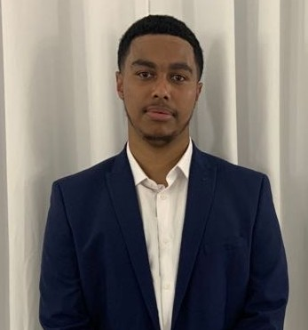
Zakaria Mounes
● contact phone: +447900650321 ● contact email:zakaria.mounes@gmail.com
Personal Profile
- I am a highly motivated and hard-working individual pursuing a professional career in the IT industry. I am seeking a long term position with an organisation that promotes personal development and opportunities for professional growth.
- I enjoy assembling custom computer systems. I am highly proficient in troubleshooting desktops, laptops, and server hardware as well as the installation, operation, and maintenance of operating systems and applications.
Technical Skills
- Troubleshooting Windows, Mac
- 1st Line Support
- Windows Server, Active directory management
- Group Policy
- Windows 10/11 Deployment
- Microsoft Office Sharepoint administration
- Microsoft Admin Centre
- Microsoft 365
- Email Security
- Papercut print management
- Laptop and PC maintenance
- Printer/Photocopier Management
- Asset Management
- Adobe, Eversign,
- Sophos Cloud administration
- Freshdesk Ticketing system
- Atera Ticketing System
- Microsoft Azure AD management
Soft Skills
- Interpersonal Skills
- Teamwork/collaboration
- Problem solving Skills
- Customer service Skills
- Calm under pressure

Employment History
London Contemporary Dance School February 2022 – Present
IT Support Technician:
- Worked alongside our MSP
- Providing administrative support to the department
- Looking after and distributing consumables and loan equipment
- Checking technical notifications and actioning/alerting other members of the team as appropriate
- Active Directory administration
- Updating and checking IT equipment inventory
- Checking daily backups and alerting of any errors
- Setting up and supporting conferencing equipment
- Monitoring, actioning and escalating IT Helpdesk calls
- Working with the IT Support Technician to provide 1st line technical support to users
- Assisting with the setup of equipment and software

In addition to providing IT support. The role evolved into liaising and leading IT projects alongside my line manager with The MSP. Below are the Projects lead and achieved.

- Migrating legacy telephones to Microsoft Teams Telephony
- Setting up basic IT infrastructure at a studio on a different site
- Server Upgrades
- Firewall changes

The Shake Lab September 2017 – September 2019
- Server and customer service
Sainsbury’s Online Assistant September 2019 – June 2021
- Picking and Packing orders
- Loading Vans ready for delivery working under a deadline

Education
GCSE’s:
- Biology= C
- Chemistry= C
- Physics= C
- Mathematics= C
- English Language= C
- English Literature= B
- ECDL ICT course= Distinction*
A Level:
- BTEC Level 3 Sports Science= Pass
- BTEC Applied Science= Pass
Professional IT Certifications
- Level 3 ICT Apprenticeship

References
  - Upon Request

