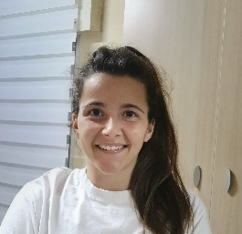 Sara Carrión Beltrán
(Spanish, English, History and Geography teacher)

□ • sara.cbf@gmail.com
• Madrid, Spain
□ +34 661 767 742

Driving license B

Experience

Spanish Teacher (December-current job)

From 10 years old to adults

English Teacher (October-current job)

Foundation Stage-Key Stage 3

Spanish as a Foreign Language (ELE) Teacher
Centro de Estudios Hispánicos, Universidad de Nebrija, Madrid January 2025 – April 2025
- Specialist in teaching Spanish from levels A1–C2 according to the CEFR.
- Communicative approach.
- Ability to teach using the CLIL methodology.

Cultural Guide
Magmacultura, Madrid June 2022 – May 2024
- Guided and informed visitors throughout the following exhibitions:
  - Klimt
  - Tutankhamun
  - Pompeii

Education

CELTA COURSE

International House Madrid- 2025

Master’s Degree in Teaching Spanish as a Foreign Language: Didactics and
Research
Universidad de Nebrija, Madrid – 2025
- Focused on the communicative approach.
- Specialization in Didactics.

Master’s Degree in Medieval Studies
Universidad Complutense de Madrid, Madrid – 2022
- Specialization in Research.

Bachelor’s Degree in History
Universidad Complutense de Madrid, Madrid – 2020
- Specific knowledge in History, Art, Geography, and Philosophy.

Skills
- Communication – Expert
- Classroom management – Expert
- MS Office Suite – Intermediate
- Design of didactic materials – Advanced

Languages
- Spanish – Native
- English – Advanced (CAE)

Interests
- Learning a new language: Arabic
References
Margarita mplanelles@nebrija.es
Miriam msajetas@nebrija.es
Irene salamatadero@madridartesdigitales.com

