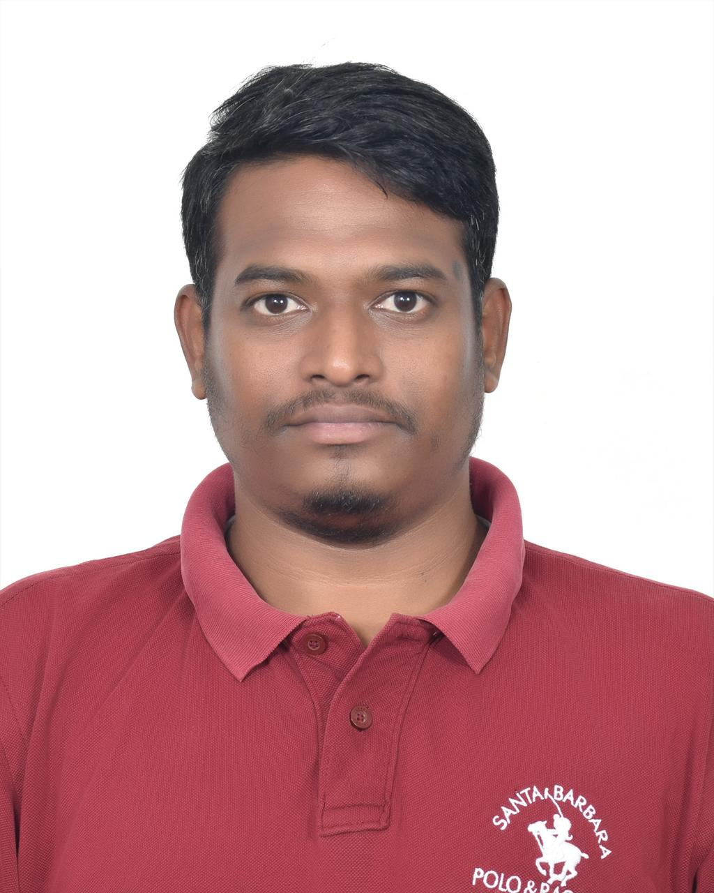

VINOD KUMAR BAVANASI
P: +91-9642825554 | E: vinodkumar.bavanasi@gmail.com | Date of Birth: 05th May 1993
Marital Status: Married
LinkedIn: www.linkedin.com/in/vinod-kumar-bavanasi16
Address: C-122, Shreshta Souther Star, Akshaya vana, Akshaya Nagar, Bangalore -560076

PROFILE SUMMARY
Seasoned IT professional with over 10 years of experience, including over 6 years as DevOps Engineer, specializing in Software Configuration Management, Build and Release Management, and CI/CD. Skilled in Git, Maven, Nexus, SonarQube, Jenkins, Kubernetes, Docker, AWS, and Azure DevOps. Expertise in Linux administration and Shell scripting for automation and process optimization. Strong background in cloud computing, infrastructure management, and container orchestration. Passionate about streamlining deployments, enhancing system reliability, and driving continuous improvement

WORK EXPERIENCE
Lead Consultant | ITC Infotech Pvt Ltd | Bengaluru | May 2023 – Till Date
ITC Infotech is a global business solutions & technology services leader, enabling future ready IT Services for clients.

Client | British Americcan Tobbaco (BAT)
Team Size | 65
Environment | Azure DevOps, GIT, and Linux
- Established, structured, and maintained Git repositories in Azure DevOps, ensuring robust access control and adherence to version control best practices
- Engineered and deployed Azure Pipelines for Development, QA, and Production environments using YAML and Classic Editor to enhance build and deployment efficiency
- Compiled and managed production and build audit reports to ensure compliance and facilitate tracking
- Oversaw organization-wide access control in Azure DevOps, ensuring proper authorization for users and teams
- Deployed, configured, and managed Self-Hosted Agents on Azure DevOps Servers to improve build efficiency and optimize resource utilization
- Designed and implemented automation scripts to activate Self-Hosted Agents post-monthly patching, minimizing manual intervention and downtime
- Automated and supervised activation and deactivation of AWS and Azure Dev/QA resources before and after weekends to reduce cloud expenses
- Directed team by assigning tasks, evaluating performance, and ensuring projects remained within budget and timelines

Senior DevOps Engineer | Sinarmas Digital private Limited | Bengaluru | May 2022 – May 2023
Sinarmas Digital is one of the leading telecommunication service provider in Indonesia for the retail and corporate segments.

Client | Smartfren
Team Size | 48
Environment | GIT, Jenkins, shell scripting, Jira, Tomcat, K8, Maven
- Supervised end-to-end build and release processes, ensuring seamless dependency coordination and deployment execution
- Implemented analytics tools within microservices and deployed them on Azure cloud infrastructure
- Set up Git integration with Jenkins and scheduled automated jobs using Poll SCM option
- Oversaw production deployment of product releases, ensuring stability and efficiency
- Organized and administered Git branches for development and deployment cycles
- Created, deployed, and refined build automation strategies
- Scripting and automating build-related tasks using Shell scripting
- Administering branching and tagging strategies to maintain version control integrity

Software Developer | HCL Technologies Limited | Bengaluru | May 2018 – May 2022
HCL Technologies Limited (HCLTech) is a global technology company that provides a wide range of IT services and solutions, including digital transformation, engineering, cloud, and AI

Client | Siemens Healthineers.
Team Size | 95
Environment | QlikSense, GIT, Jenkins, shell scripting, Jira, Tomcat, Kubernetes, Docker, and Azure DevOps
- Implemented and fine-tuned CI/CD delivery pipelines on Azure DevOps
- Automated build process leveraging Git and Maven
- Streamlined application packaging and deployment through automation
- Configured Jenkins to automate build process and managed complete Build and Release lifecycle, encompassing code, documentation, testing support, and server administration
- Operated and maintained Linux staging and testing platforms
- Defined and enforced coding standards through automated tools like SonarQube
- Provided training on continuous integration and automated testing best practices, offering ongoing support throughout development
- Set up Azure CI/CD pipelines to run nightly builds and produce change logs summarizing updates from last 24 hours
- Integrated testing tools like JUnit to enable unit testing and code coverage reporting with detailed visual analytics
- Linked continuous integration system with Git repository, ensuring automatic builds upon developer check-ins
- Diagnosed and resolved source code merge conflicts in Git
- Wrote and fine-tuned Maven and Shell scripts to improve deployment automation
- Provisioned and managed Virtual Machines in Azure
- Authored PowerShell scripts to automate installation of QlikSense tool

System Engineer | Cadential Technologies Pvt Ltd | Bengaluru | Aug 2014 – May 2018
Client | AbbVie Healthcare Pharmaceuticals Inc
Team Size | 46
Environment | Windows, Linux, Firewalls, and QlikSense
- Installed, configured, and maintained desktops and peripheral devices, including printers and scanner.
- Administered network devices such as routers, switches, and firewalls to ensure stable connectivity
- Monitored and troubleshot network connectivity issues to maintain uninterrupted operations
- Deployed, upgraded, and resolved issues related to Windows and Linux operating systems, as well as business applications
- Enforced and managed endpoint security measures, including antivirus, anti-malware, and firewall protections
- Ensured routine data backups for desktops and shared resources to prevent data loss
- Liaised with vendors for hardware procurement, internet services, and software license management
- Controlled and streamlined cloud infrastructure encompassing Office 365, OneDrive, and Google Workspace
- Configured and maintained Qlik Sense Enterprise in both single-node and multi-node environments
- Applied Section Access to enforce row-level security in Qlik Sense
- Defined and managed security rules, roles, and access permissions using QMC

EDUCATION
- Bachelor of Technology from St. Ann's college of engineering and technology, Kakinada, India - Jan 2014

SKILLS
- Scripting Tools: | Shell Scripting, PowerShell
- Containerization Tool: | Docker
- Orchestration Tool: | Kubernetes
- Application Server: | Tomcat And NGINX
- Version Control Tool: | GIT, Azure DevOps
- Continuous Integration / Deployment Tool: | Jenkins, Azure CI/CD
- Build Management Tools: | Maven
- Cloud Environment: | AWS, Azure
- Artifactory Tools: | Nexus
- Ticketing Tool: | Jira, Azure VSTS, and TFS
- Database | SQL
- Monitoring Tools | New Relic
- Code Coverage Tools: | SonarQube
- Cache Server: | Redis
- BI Tools: | Qlik Sense
- Operating System: | Linux, Windows

FUNCTIONAL SKILLS
- Software Configuration Management
- Build and Release Management
- Continuous Integration/Continuous Deployment (CI/CD)
- Infrastructure Automation
- Cloud Resource Management
- Access Control & Security Compliance
- Monitoring & Issue Resolution
- Network & System Administration
- Artifact & Package Management
- Collaboration & Agile Practices

CORE COMPETENCIES
- Proficient in Git for branching, merging, and managing user permissions, ensuring efficient version control
- Automated builds using Jenkins and Azure CI/CD, reducing deployment times by 40%
- Installed, configured, and managed Jenkins, including plugin management, job creation, and automated notifications
- Improved system reliability by monitoring application servers and troubleshooting performance issues with New Relic
- Deployed and maintained artifacts in Nexus and Azure, ensuring proper version control and traceability
- Developed Shell scripts to automate routine tasks, improving operational efficiency
- Worked closely with developers to support daily continuous integration, ensuring timely and stable builds
- Designed and implemented scalable, reliable, and automated deployment strategies

