TOLULOPE HANNAH FAJUGBAGBE

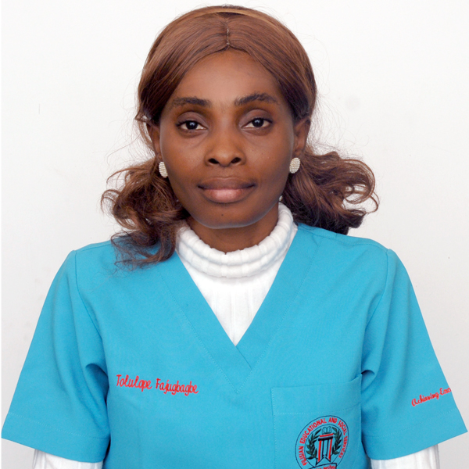

NURSING ASSISTANCE

CONTACT ADDRESS: MANAMA, BAHRAIN

GENDER: FEMALE

NATIONALITY: NIGERIAN

DATE OF BIRTH: 10TH NOVEMBER,1987

MOBILE NUMBER: +973 33187036

E-MAIL: tolulopefajugbagbe@gmail.com

OBJECTIVES
Dedicated and compassionate healthcare professional with proven reliability and strong interpersonal skills, eager to join a team as a healthcare assistant . Skilled in providing personalized care, companionship and support with patience and dignity. Experience in BLS, ADL and health monitoring committed to fostering meaningful patient relationship and ensuring well being.

ACADEMIC QUALIFICATIONS
- Ladoke Akintola University of Technology, Ogbomoso. 2011
OyoState. Nigeria. Second class honour B. Tech Physiology
- Filisian Education Institute, Adiya, Kingdom of Bahrain 2025
Distinction in Diploma in Nursing and Patient Care
PROFESSIONAL QUALIFICATIONS
- Joint professionals training & support int’l (HSE) 2013
- Diploma in caregiving at Alison’s Education 2024
- Vital sign: understanding what the body is telling us at Coursera Aug 2024
- Engineering health: Introduction to yoga and physiology at Coursera Sep 2024
- Supporting families and caregivers in Coursera Nov 2024
- Diploma in Nursing and Patient Care at Alison’s Education 2025
- ECG Rhymes and interpretation at Alison’s Education 2025
- CPR, AED, and first aids at Alison’s Education 2025
- Certificate of participation in teachmeet at Nadeen school Bahrain 2025
- BLS Certificate accredited by NHRA and AHA in KIMS hospital Bahrain 2025
WORK EXPERIENCE
- Nursing Assistant / Caregiver in a private residence at Dilimunia Bahrain 2023 till present
Duties:- Taking vital sign, preparing meal, Assisting in activities of daily living, assist in exercise, changing of cloth and bed making, peg tube, catheter care, stoma care.
- Nanny and Housekeeper in private residence at Essence of Dilimunia Bahrain 2022 -2025
Duties: - Caring for kids, cleaning and tidying of apartment
- Internship at King Hamad America mission hospital Bahrain 2025
Duties:- Bed making, Assisting in daily activities and personal care, asking call bell, changing positions, transfer of patients, assisting nurse.
- Caregiver in a private residence at seebi estate, Akure, Nigeria. 2015-2022
Duties:- Taking vital sign, preparing meal, Assisting in activities of daily living, assist in exercise, changing of cloth and bed making.
- National Youth Service Corps in Ogun State Hospital, Ijebu-Ode. Nigeria 2012-2013
Duties: - Electrocardiography Examiner, Attending to patients,
- Lautech Teaching Hospital, Osogbo, Osun State. Nigeria (Industrial Training) 2010
Duties: Electrocardiography examiner, Documentation of Patients Data.
SKILLS AND ATTRIBUTES
- Empathy, Compassion and Patience
- Ability to take good care of patients, provide health education and attentive to detail.
- Ability to take vital sign measurement, assisting with activity of daily living, perineal care, Mobility assistance and transfers, Meal preparation and feeding support, and wound management
- Excellent communication skills.
- Response effectively to emergencies and followed care plans precisely and infection control.
- Housekeeping and errands
- Ability to work with or without supervision with strong analytical mind.
- Ability to working as a team
- Ability to maintain testing equipment’s, Patient record maintenance
COMPUTER SKILL
Skill in using personal computer, Proficient in Microsoft Suit
DECLARATION
I declare that all the above statements are true to the best of my knowledge. I assure if you that if you give me a chance to serve under your guidance, I shall try my best to your concern by my hand and honest work

