RESUME
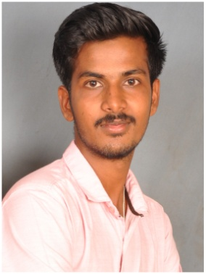

B.JAYA BHARATHY

Address:
661,Kalayambadi Street,
Gandarvakkottai(PO & Tk)
Pudukkottai (Dt),
Pin code: 613 301, Cell: +91- 9047643788
Tamil Nadu, E-mail: jeybrj@gmail.com
India.

Career objective:

To pursue a challenging and creative job career in your organization where I can apply my customer service skills and creativity, to acquire more knowledge and contribute well to the organization.

Academic Chronicle

- I have completed B.Sc., [HM&CS] 2014-2017 in Bharath College of Science and Management [Bharathidasan University, Trichy].

Personal profile:
- Father’s name : NPS.BALU.
- Date of Birth : 30. 07. 1997.
- Sex : Male
- Marital status : Married
- Nationality : Indian
- Language known : Tamil & English (Read&Write)
Malayalam (Can Speak)

Work Experience:

S.No | Company Name | Place | Designation | Duration
1 | Omega Healthcare | Trichy,  India | Executive - AR Caller | 1 Year 3 Months (2022 – 2024)
2 | Sangam Hotel | Thanjavur,  India | Sr.Front Office Associate | 5 Months  (2022-2022)
3 | Cardinal Pharmacy W.L.L | Hamala, Bahrain | Admin Coordinator | 6 month  (2021-2022)
4 | Awal Recidence | Manama, Bahrain | Receptionist | 2 Years  (2019-2021)
5 | SRM Hotel Pv Ltd | Trichy,  India | Front Office Associate | 1 Year 6 Month  (2018-2019)
6 | Svatma Heritage Residence | Thanjavur,  India | Front Office Associate | 1 Year  (2017-2018)

Training Experience:

S. No. | Hotel Name | Place | Department | Training Duration
1 | Avenue regent | Cochin, Kerala | Front Office | 01.12.2014-10.01.2015
2 | Wind flower resort & spa | Pondicherry | House keeping | 10.05.2015-15.07.2015
3 | Ramoji film city | Secundrabad | House keeping | 01.12.2015-17.01.2016
4 | Gold finch | Bangalore | F&B service | 10.05.2016-10.07.2016
5 | Wind flower resort & spa | Pondicherry | Front Office | 27.11.2016-10.01.2017

Computer skill:
  - Imagine Medical billing Software
  - WINHMS hotel Software
  - Opera Hotel Software
  - PosiBolt ERP Pharmaceutical
  - IPOS Point of sales
  - Online C form(Indian Bureau Immigration)
  - Email access
  - M.S.Office
  - Internet

DECLARATION:

I hereby declare that the above mentioned details are true to the best of my knowledge and belief.

Date: Yours faithfully,

Place: B.JAYA BHARATHY.

