SHAIK AESAR
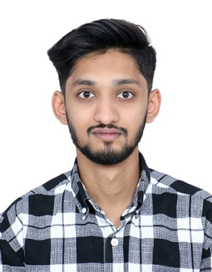

Bengaluru, Karnataka, India
Mobile: +91 8748059655
Email: shaikaesar0@gmail.com
PROFILE SUMMARY
- Demonstrated proficiency and expertise gained through 2.5 years of hands-on experience in various roles within collection management, customer relationship management, and data analysis.
- Proficient in leading collection efforts, and ensuring timely payments while maintaining positive client relationships.
- Demonstrated ability to nurture client relationships, resolve issues effectively, and provide exceptional customer service.
- Experienced in analyzing data to identify trends, patterns, and areas for improvement, contributing to informed decision-making.
- Proficient in utilizing Microsoft Excel for data manipulation, analysis, and reporting purposes.
- Well-versed in utilizing various communication tools to facilitate collaboration and streamline processes within the team.
- Proven track record of leading teams to success through mentorship, training, and strategic guidance, fostering a cohesive and productive work environment.
- Adept at identifying and resolving issues efficiently, utilizing analytical thinking and creative problem-solving techniques.
- Skilled in negotiating with stakeholders to achieve mutually beneficial outcomes, leveraging strong interpersonal and communication skills.
- Committed to delivering exceptional customer service, addressing client inquiries and concerns promptly and professionally.
- Proficient in cultivating and maintaining positive relationships with clients, stakeholders, and team members, fostering collaboration and trust.
AREA OF EXPERTISE
Collection Management | Customer Relationship Management (CRM) | Data Analysis | Microsoft Excel | Communication Tools | Leadership | Problem-Solving | Negotiation | Customer Service | Relationship Management | Team Leadership & Management | Cadence | CPQ | Business Analysis | Team Cohesion | Demand Creation | Accounts Receivables | Lead Handling | Business Relationships | Problem Resolution | Capital Freight management | SPA
WORK EXPERIENCE
Collection Analyst (Team Lead) ~ Sep 2022 – Present
Invensis Technologies Pvt Ltd, Project company (eCapital Freight factoring company)
- Lead a team of 12 members, providing mentorship, training, and support to ensure peak performance and professional growth.
- Cultivated a synergistic and results-oriented team environment through strategic leadership and motivation, contributing to departmental success.
- Developed expertise in collection management, leadership, problem resolution, and fostering team cohesion.
- Conducted detailed investigations of issues and collaborated with stakeholders such as shippers and brokers to achieve mutually beneficial solutions while providing exceptional customer service.

Business Analyst ~ Jul 2021 – Aug 2022
Oracle, India
- Supported Oracle's tools including SPA, CPQ, Oracle Sales Environment, Demand Creation, Lead & Deal Handling, Prediction, Client Engagement, and Sales Director Hub.
- Provided assistance to sales personnel, offering answers to inquiries and ensuring familiarity with selling procedures and regional jurisdictions.

NOTEWORTHY ACHIEVEMENTS
- Earned rapid promotion to the position of Team Leader within a mere two-month timeframe highlighting exceptional performance.
- Garnered commendations from esteemed clients.
- Honored with the "Gem Award" for outstanding performance and dedication beyond expectations.
EDUCATIONS
Bachelor of Commerce from Dayananda Sagar University, India | 2018 - 2021

