Curriculum Vitae
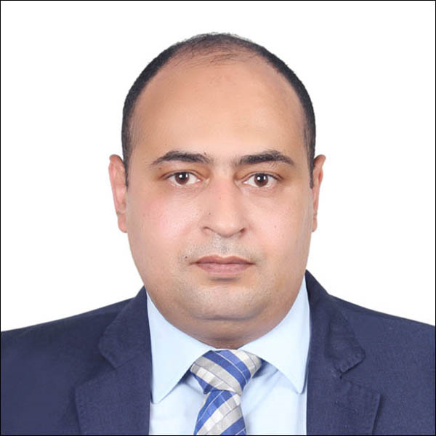
First name(s) / Surname(s) :- | Munther Ismail Mahmoud Abu Douleh .
Postal Address :- | The Hashemite Kingdom of Jordan – Zarqa – Bab Alwad Street – Post Office - PO.BOX 5941 Postal Code 13111 .
Address-/Jordan :- | Jordan_Amman_Jubiha.
Address-/Kuwait :- | Kuwait_Hawalli_Salmiya.
E-Mail :- | munther_kuwait_77@hotmail.com
Mobile number/Kuwait :- | 0096597513391
Mobile Number/Jordan :- | 00962796964463
Nationality :- | Jordanian .
Languages :- | - Arabic :- Mother Tongue .  - English :- very good .

Academic Qualifications
University Qualification | Bachelor's Degree in Law with Honors and A rate of 85.1% - The Top five.

Work experience
- Typist & Clerk in The Jordanian Ministry Of Justice – Court Of Zarqa
Dates :-
From 01/02/2007 To 12/02/2008.

Main activities and responsibilities :-

- Print judicial transcripts.
- Preparing files for judicial complaints.
- Data Entry for lawsuits.
- Scheduling court hearings.
- Answer public inquiries.
- Receiving requests for judicial appeal.
- Blogging in court records.
- Judicial correspondence.
- Prepare parties invitations.
- And much more tasks.

- Auditor Assistant in Jordanian Audit Bureau:-

Dates :-
From 12/02/2008 To 13/05/2015

Main activities and responsibilities :-

First :- Field Audit through Field Offices on Institutions and Governmental Ministries and Commissions Covered by the Supervision of the Audit Bureau :-

Tasks :-
- The application of effective control over compliance with laws and regulations, instructions and contracts and licensing requirements in all aspect of institutional activities.

- Auditing Governmental Accounts.
- Implementing the following sudden tests: -
- Sudden inspection on cash on hand.
- Sudden inspection on warehouses.
- Sudden inspection on cars movement.
- Sudden inspection on the commitment of attend.
- Examination of the internal control systems.
- Sudden inspection on the Financial advance.
- Any sudden tests required by the nature of work.
- Participation in the executive and supervisory committees Such as :-
- Committees of opening tenders Offers (Financial And Tenchnecal).
- The technical committees to study and recommend awarding .
- Committees of procurement and bidding at all levels and sessions of Final awarding .
- The receipt committees.
- Preparing instructions and systems Committees .
- Auditing and investigation committees .
- committees of investigation.
- Participate in committees of determining the rate of fuel consumption of governmental cars.
- Any other committees required by the nature of the work.

- Auditing of warehouses and extracting increase and shortages and preparing the necessary reports.
- Auditing of sections of vehicular movement and preparing the necessary reports.
- Auditing of personnel and review the extent of matching with the governing legislation and preparing the necessary reports.
Second: - The main tasks in the Audit Bureau Main Center: -

- The official of “Auditing and investigative committees” in the Directorate of Legal Affairs at the audit bureau: -

Tasks :-

- Follow-up “Audit and Investigative Committees” files and preparation of the necessary Correspondenceto the Concerned ministries, Institutions and Governmental Commissions .
- Preparing The necessary reports on the progress of the work.

- Assistant Auditor in the Administrative Control Directorate at the Audit Bureau: -

Tasks :-

- Follow-up the files of administrative Irregularities seized in Ministries And Institutions, Governmental Commissions , and recommend the necessary correspondence.

- Auditing of governmental cars irregularities before they are submitted to the Prime Minister.
Third: - assigned tasks by the Audit Bureau at Institutions and Ministries and Governmental Commissions Under the supervision of the Audit Bureau :-

The head of internal control unit in the Jordanian Medical Council.

Tasks: -
- The application of effective control over compliance with laws and regulations, instructions and contracts and licensing requirements in all aspect of institutional activities .

- Establishing the internal control unit .
- Design Job forms .
- Preparing work programs .
- preparing the annual plan .
- Linking to the Secretariat of the Medical Council of Jordan and the rest of the departments within the organizational structure.
- Participation in audit and investigation committees .
- Participation in investigation committees.
- Supervise the work of the Administrative Control section.
- Supervise the work of the financial control section.
- Supervise the work of the internal control section
- Staff training on the agenda of censorship.
- Participation in the Secretariat meetings to express an opinion about what poses in meetings to approve or impounded.
- Preparing legal, financial and administrative opinion to submit it to the General Secretariat .
- Preparing the periodic and annual reports and submitting it to the Secretary-General.
- Any other duties related to the work of internal control unit.

- Administrative Supervisor in SABIS Facilities Management Servises (L.L.C).

From 18/11/2015 – 23/6/2016 .

- Dealing with Students infractions .

- Teachers / staff Infractions: (Report and record teacher s infractions).

- Other tasks .

- Legal researcher in Ministry Of Social Affairs in Kuwait state :-

From 08/10/2017 to 31/12/2021.

- 5.First Legal researcher in Ministry Of Social Affairs in Kuwait state :-

From 31/12/2021 until now.

Tasks: -

Legal Studies & Fatwa Department:

- The functional tasks of the Legal Studies and Fatwa Department are divided into two parts, advisory and executive.
- Advisory Division:
- Responding to the inquiries of the various sectors of the ministry operating within the organizational structure of the Ministry of Social Affairs, which arise in the occasion of its practice of its work and its relations with the natural and legal persons associated with it in light of the laws and regulations governing the work of the Ministry and its relations with the various entities.
- Executive Division
- Receiving, studying and responding to lawsuits filed by others against the Ministry of Social Affairs and following up on the developments of these cases before the judiciary in different degrees of litigation, whether they are being dealt before a court of first degree, appeals, or discrimination, as well as filing cases from the ministry against others in the field of the ministry’s work, as well as Address the various government agencies related to the work of the ministry in light of the legislation that regulates its work.
- Following up on the cases filed by and from the Ministry of Social Affairs, the necessary internal correspondence is prepared to request information and data from the various sectors of the Ministry to prepare the Ministry's responses and defense memoranda thereof, and to provide the Fatwa and Legislation Department with them, as it is the entity assigned with representing the Ministry before the courts.
- Experts' sessions are also attended to represent the Ministry, submit defense memoranda thereof, and participate in discussions on the merits of the cases referred to the Experts Department under the referral provisions.
- Representing the Ministry before the competent prosecution offices according to its mandate, in addition to its representation in various other entities.

- Committees and working groups

- Legislation Review and Drafting Team.

- The Coordination and Follow-up Committee for the Supervision and Control of Associations and Cooperative Unions.

Courses and workshops

- Preparation of new auditors “ period of training for six months”.
- Accounting For non-accountants.
- Auditing using statistical sampling.
- Advanced Financial Analysis.
- Modern methods in the detection of fraud and forgery.
- A workshop entitled” the role of self-evaluation in strengthening the work of the internal control units and determine future steps
of reform”.

Computer courses

- Computer maintenance A +
- Printing in Arabic and English at a rate of 45 words per minute.
- Microsoft's Windows software, Word, Excel, PowerPoint.

Other skills

- All administrative skills and the use of office equipment.
- Learn new skills quickly and easily.

