PROFIL
I am an enthusiaﬆic and dynamic individual, graduated in business. My goal is to ﬆart my career in business as a junior sales representative, where I can apply my communication and persuasion skills.

EDUCATION
2017-2019
Specialized technician in commerce
ISTA POLP
2016 – 2017

Bachelor's degree in life and earth sciences
JAFAR EL FASSI FIHRI, Hight school

PROFESSIONAL EXPERIENCE

2019-2021

2021-2022
Commerce
Reading about sales and negotiation techniques.
Engaging in amateur theater to improve my communication skills.
Participating in market trend discussion groups.



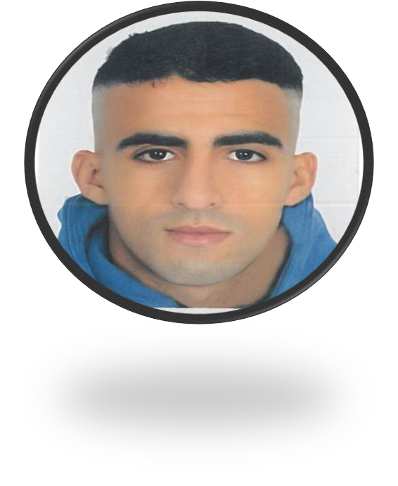
Active liﬆening Service orientation Teamwork
Adaptability
SKILLS
Word Excel
Power Point
COMPUTER SCIENCE
LANGUAGES

Arabic : native language Franch : advanced level
English : basic knowledge
06 45 13 45 71
Hay molay Rachid massira 1 Bv Khalifa ibn Ismail imm 12 aprt 3 Escobarkhalil126@gmail.com
Driver's license
CONTACT

KHALIL JAOUCHI

2023

2023
Commerce
Reading about sales and negotiation techniques.
Participating in market trend discussion groups.

The mission of the Football League is to promote, organize, and manage professional football to ensure its development, integrity, and continuous growth.

Commerce
Generate and develop the company's sales.
Expand the client portfolio through sales and prospecting techniques.

