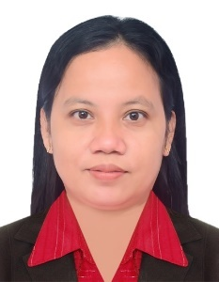
LORELYN S. REYES
Building 1748, Road 635, Flat 12, Block 306
Ras Rahman, Bahrain
+97337509943 / WhatsApp : 35448607
lorelynreyes87@gmail.com
To pursue a challenging career, leadership with dedication, and provide my efficiency to the fullest in a professional organizational environment whatever I serve my duties will discover my potential.

EDUCATION

ENGLISH FOR BUSINESS AND ENTREPRENEURSHIP
Technical Education Skills And Development Authority
Philippines
Completion Date : August 2, 2022

Introduction to Front Office Service
Technical Education Skills And Development Authority
Philippines
Completion Date : August 7, 2022

Graduated with a degree of Master in Education
Major in Educational Administration
Golden Gate Colleges
Philippines
August 6, 2015

Bachelor of Secondary Education
Major in Filipino
Batangas State University
Philippines
April 21, 2003

WORK EXPERIENCED

Secondary Teacher
Philippines
December 12, 2004 – July 31, 2022

Part-time:

- Real State Agent for 2 years
- Managing business online for 5 years

Professional Skills
- Knowledgeable in using Canva applications and MS office
- Creative and enthusiastic
- Have excellent communication
- Know how to handle and solve problems
- Have strong work ethics
- Knowledgeable in using computers and the internet

PERSONAL INFORMATION
Date of Birth : July 23, 1982
Religion : Roman Catholic
Marital status : Married
Language : English / Filipino
Contact number : +97335448607
Nationality : Filipino

I hereby certify that the above information is true and correct to the best of my knowledge and belief.

LORELYN S. REYES
Applicant

