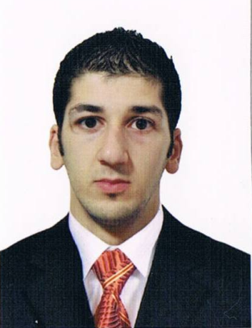
CV

Name : Abedel hafid / BESSAID
Date of birth : 07-06-1992 at BAB el Oued-
Algiers.
Nationality : ALGERIAN.
Family situation : Single.
Address : City 140 Longmont N °137 eucalyptus – Algiers
Phone number : +213(0675848116 ), +213(0778 267 473)
E-mail Address : hafid2022@hotmail.com
Language: Arabic, French, English
Education :
- Third secondary
- Certificate of qualification (Air conditioner)
- Certificate of qualification (Plumber)
- Certificate High Technical (stock management)
Skills :
Driver's license , Training Excel Word, Training software Intellix , Experience (stock, purchase and logistics), Experience ( plumber General. Air conditioner. Central heating
Gas, water, Central heating).
Work experience :
- 36 months technical service plumber (Sarl rck).
- 06 months technical service Air conditioner ( Sonatrach)
- 36 months technical service Air conditioner (Hotel Hilton).
- 24 months Stock Management and storekeeper (Hotel Du val).

