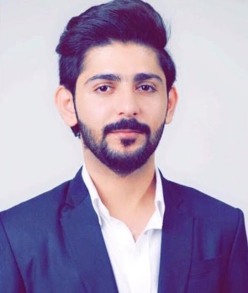
Bilal Manzoor Ahmed

- albalushibilal2@gmail.com
- 37158658

Personal Data
Nationality: Bahraini
CPR No.: 971216045
Date of Birth: 27 Dec 1997
Gender: Male

Objective
To make optimum utilization of my knowledge and skills, utilize opportunities effectively for professional growth and to contribute in the best possible way for the betterment of the organization and self.

Education:

2020: Cisco certified Network Associate 200-301

2021: Extended Diploma IT (Networking) Bahrain Training Institute.
- Cisco Exploration Routing Protocols & Concept
- Managing Networks
- Configuring Windows Server 2008 Network Infrastructure
- Cisco Exploration Network Fundamentals
- IT Technical Support
- Communication Technologies
- Configuring Windows Server 2008 Active Dir
- Computer Networks
- IT Systems Troubleshooting and Repair.

Experiences:

- Swiss-Belsuites Admiral Juffair W.L.L (1-year experience) IT coordinator
- Parking Lot Restaurant (3-year experience) IT coordinator

Achievements:

- Awarded for Abu Abdullah Khawarizmi Prize in EBTIKAR 5 as 1st Place.” IOT PROJECT as Smart light “.
- Awarded for BTI skills program “cabling”
- Awarded for Best leadership student
- Awarded for estimate of the attendance
- Actively involved in Small Business 1st place.
Duties and Responsibilities:
- Design procedures for the use of IT resources
- Advise management with the goal of making the appropriate IT decisions and choices
- Provide technical support to all employees
- Design, plan and execute training on the use of systems and networks
- Install and configure hardware equipment and software programs
- Oversee, track and measure system and network performance
- Perform troubleshooting and execute needed repairs
- Execute different maintenance activities when needed
- Review and develop security-related contract documents
- Work with other IT professionals to ensure upholding IT standards

Areas of Interest
- Communicating, Browsing, meeting new people, Editing & entering Data.
- Amazon web services
- Networking

Competencies and Skills
- Networking skills.
- Customer Service Skills
- Cabling skills.
- Microsoft Office Computer “Word, Excel, PowerPoint, Access, Visual Studio, Publisher & Different Type of PC Applications.
- Using Database information.
- Browsing new information around the world.
- Patience, Commitment, Confidence, working under pressure and Teamwork

Hobbies
- Looking for unique information
- Photography
- Electronics
- Video editing
- Gaming

Languages known

- ARABIC
- ENGLISH
- Urdu & Hindi
- Balochi

