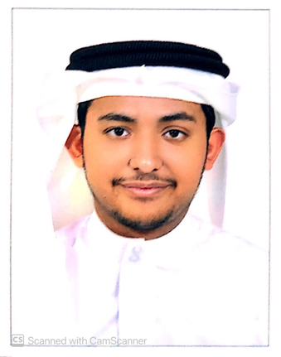
CURRICULUM VITAE

OBJECTIVS

Looking forward to associate myself with an organization of quality environment where knowledge can be shared and dedicate my skills and talents for development of self and the organization served.

PERSONAL DETAILS

- Name : Nawaf Ahmed Ali Yusuf alhamar
- CPR No. : 011102659
- Date of Birth : 08/11/2001
- Nationality : Bahrain
- Gender : Male
- Marital Status : Single
- Contact No. : 36368683
- Address : Bldg- 1298, Road-4431, Block- 244 Arad

EDUCATION

- Secondary School Certificate.

LANGUAGE

- Arabic: Writing, Reading and Good Speaking.
- English: Writing, Reading & Fluent Speaking.

ADDITIONAL SKILLS & EXPERIENCE

- Computer MS. Office Course.
- I have Driving License private.
- Communication skills.
- Hard work Skills.
- Work under any circumstances.
- No problem to work alone or with group.

HOBBY

- Play foot boll

- Reference available upon request.

