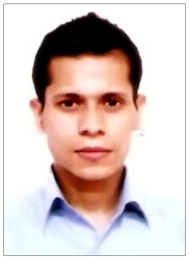
AMIR CHHETRI
E-mail :amirchhetri30@gmail.com
Contact No: +973-36917995

CAREER OBJECTIVE
To work in cross-functional environments and be a specialist in the field of Food and Beverages for
Hotel Industry while working in an organization which believes that providing independence along with
accountability leads to growth.

Professional Experience

- 2020- Worked as a Waiter at Mansouri Mansion Hotel, Al-Adliya, Bahrain.
- 6 months industrial training from Hotel Abu Palace (3 star ) in Chennai.
- 2 years experience as a Captain at Kitchen Family Dining Restaurant in Trichy (Tamil Nadu)
- 2 years experience as a waiter at Relish Unique Dining & Bar in Goa.

PROFESSIONAL SKILLS

- Check-in
- Check-out
- Handling Reservation
- Email Handling
- Calls Handling
- Guest Receiving
- Handling of Complains
- Taking Guests orders
- Serving Food & Beverages to the guests

ACADEMIC QUALIFICATION
- Diploma in Hotel Management from Food Craft Institute,Darjeeling affiliated to (NCHMCT) in 2012.
- Diploma in Computer Application from Manipal Institute of Computer Education.
- 2009-2011- Senior Secondary in Commerce Stream from NIOS, New Delhi.
- 2008-2009- Secondary from NIOS, New Delhi.

COMPUTER PROFICIENCY

- MS Windows
- MS Word
- MS Excel
- MS Outlook
- MS PowerPoint
- MS Access

PERSONAL DETAILS
Date of Birth : 23-09-1992
Father’s name : Late. Bhoj Bahadur Chhetri
Hobbies : Reading books and newspapers
Nationality : Indian
Sex : Male
Marital Status : Single
Religion : Hindu
Permanent Address : HMD Line, Jaigaon-736182, Dist.- Alipurduar (West Bengal)
Present Address : Manama, Bahrain.
Languages Known : English, Hindi and Nepali.
Passport Number : Z3732812
Passport Expiry : 24-05-2026
CPR Number : 920965091

DECLARATION,

I hereby declare that the above written details are true to the best of my knowledge and may be supported by
relevant documents when needed.

AMIR CHHETRI

