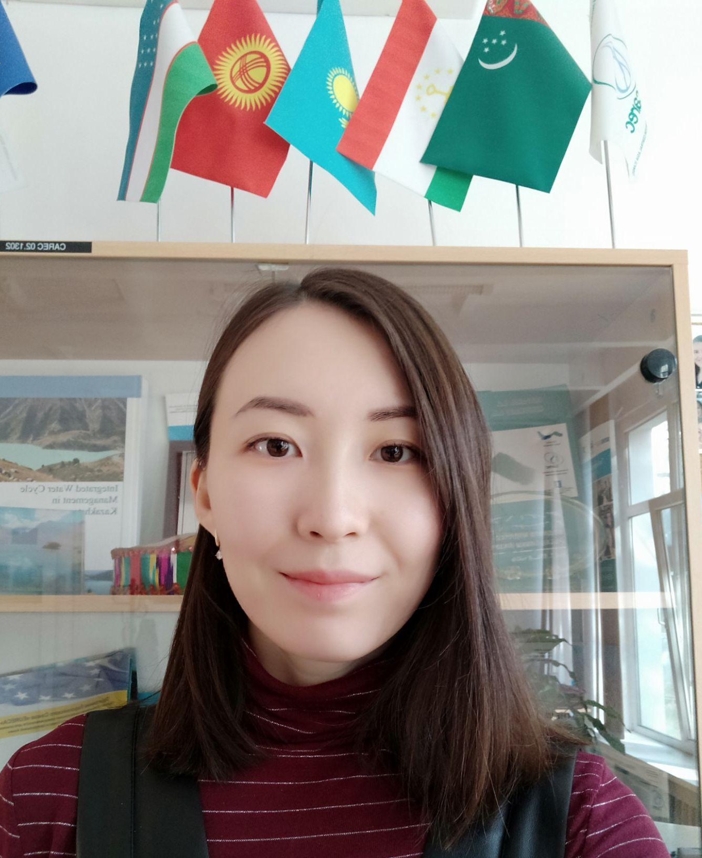
Dinara Samekova
I wish to work in an environment which encourages employees to succeed and grow professionally where they can utilize their skills and knowledge appropriately.

14.11.1994.
+973 38003483
dinarabale@gmail.com

EXPERIENCE

The Regional Environmental Centre of Central Asia, Almaty – Programme Assistant
July 2021 – May 2022
- Be in charge of logistics;
- preparing documents for the financial department;
- assistance with organization of events.

Visa Application Centre, VFS, Nursultan – Visa Manager
February 2021 – June 2021
- Managing the process of application for Schengen Visa.

Air Astana, Nursultan – Crew liaison officer
August 2019 – February 2021
- arrangement of transportation for Crew members;
- preparation of documents for flight.

Visa Application Centre, VFS, Shanghai – Visa Manager
March 2018 – November 2018
- Managing the process of application for Russian Visa.

MFA of RK, Nursultan – Intern at the Department of political monitoring and forecasting
March 2016 – May 2016
- analysis of information from the embassies of RK;
- report to the head of the Department.

SKILLS
Languages: English (7.5 IELTS), Kazakh (mother tongue), Chinese (HSK 5), Russian (native speaker).
Other: Outlook, Office Word, Power Point, Excel, Aims.

EDUCATION

上海师范⼤学/ Shanghai Normal University
September 2016 – July 2019
Master’s Degree in International Relations.

Eurasian National University, Nursultan
September 2016 – July 2019
Bachelor of Oriental Studies, Sinology.

AWARDS
Chinese Government Scholarship – 2016-2019
Fellowship of the first President of kazakhstan – 2014

