MELİH ŞEN

EDUCATION İNFORMATİON

University Uludağ University / Agricultural Enginering
2008 - 2014

Pre Licence Uludağ University / Foreign Language (English)
2007-2008

High School Zühtü Özkardaşlar High School 2004 - 2007

BUSSINESS EXPERİENCE

Balıkesir Seed Comp. / TURKEY 09/2015 – 10/2021
Agricultural Engineer
- Quality control of seeds and determination of germination rate in the laboratory.

- Preparing the seeding, planting, irrigation, fertilization, spraying plan of the determined varieties on the companyl field.

- Communicating with other companies in seed import-export, preparing documents and organizing transportation, search for new marketplace.

-
A101 Supermarket / TURKEY 04/2015 - 09/2015
Assistant Director
-Supervision of store personnel and preparation of daily sales report

COURSE / CERTİFİCATES

Computer Management Course 2003
Republic of Turkey Ministry of National Education

Bee Breeding Course 2013
Bursa vocational training course

Fruit Tree Pruning Course 2013
Bursa vocational training course

Foreign trade information seminar 2021
Republic of Turkey Ministry of Commerce

COMPUTER KNOWLEDGE
Word, Excel, Powerpoint : Very Good

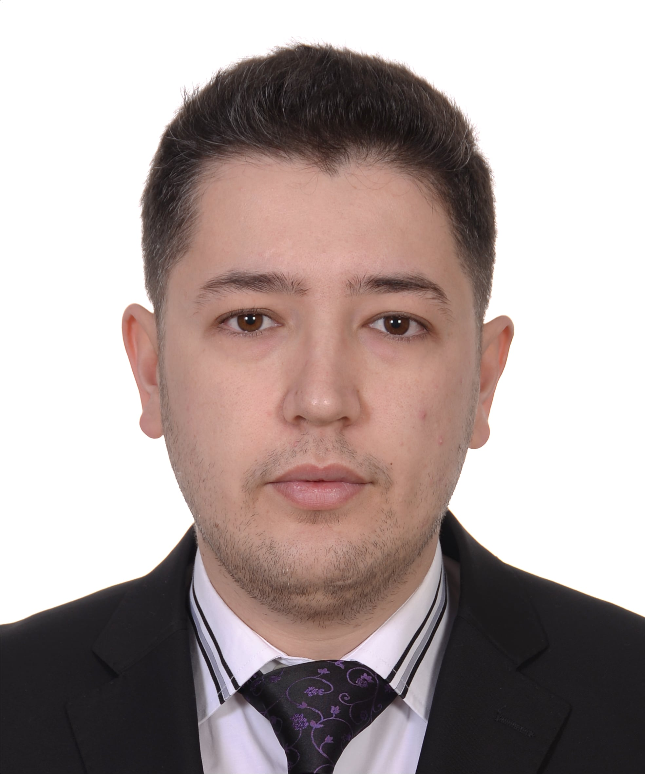

City: BALIKESİR/
TURKEY
GSM: +90 554 483 1788
mmelihfb1@gmail.com

Personal Info
Gender: Male
Born Date: 30/09/1989
Marital Status: Married
Nationality: Turkish
Drive Licence: B
(Car,Pick-up,Van )
Military Service: Done
(05-11/2017)
Height: 181 cm.

Foreign languages
English:
Read: Very good
Write: Very good
Speak:Very good

