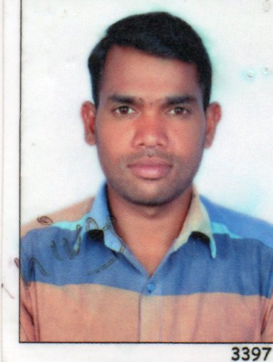
SRINIVAS CHEKKALA
MANMA CENTRAL KING DOM OF BAHRAIN
PHONE +973 35026143
EMAIL ID Sri 22chekkala@gmail.com
LICENCE TYPE BAHRAIN VALID LICENCE
OBJECTIVE:
I am an approachable, motivated and confident Sales Executive with the ability to excel sales targets and make a real difference in the organisation’s revenue generation. I have expert knowledge of the selling process and I fully recognise the human and emotional aspects of buying and selling. I possess strong social skills that enable me to be a strong relationship builder with clients, colleagues and third-party stakeholders.
Work experience

Delivery & sales Man in Spear Head Technology & Equipments W.L.L All Hospitals and Hose Delivery in All over In Bahrain
01/05/2019 Till Date

Juffair Gate hotel in juffair bahrian Jun 2019 Sep 2019.

Office Boy– Oct 2007– Jan 2009
Employers name – M/s.Gulf Golden East At Bahrain,

Waiter– Jan 2009 – July 2010
Ambhika Hotel Koyambed in Chennai, India

Aircraft Cabin Cleaning at Dubai Airport– Aug 2010 - September 2012
Employers name – Mx Care (Dnata) Group Connecting Company Dubai Airport

Team Leader (Aircraft Cabin) – SEP 2012 – Aug 2013
Employer Name: (MX Care) Connecting Company (Emirates Group) Dubai AirPort

EDUCATION:

Higher Secondary School Certificate,
Secondary School Certificate,
COMPUTER KNOWLEDGE:
Basic computer Knowledge, Internet Net Surfing & M.S Office,
Driving Licence Bahrain :
Licence No : 890121850
Type of vehicle : light
Date of Issue 27/02/2019
Date of Expiry : 27/02/2024
PERSONALB DATA
Name : Chekkala Srinivas
Date of Barth : 25/01/1994
Gender : Male
Marital Status : Married
Nationality : Indian
Language Know : English, Hindi, Tamil,& Telugu,
Passport : P 2127014 UP TO VALID 05/ 2026
Visa Status : EMPYAMENT VISA
Declaration
I am confident of my ability to work in a team I hereby declare that the information furnished above is true to the best of my knowledge...
Place: King Dom of Bahrain, SRINIVAS CHEKKALA

