Curriculum Vitae
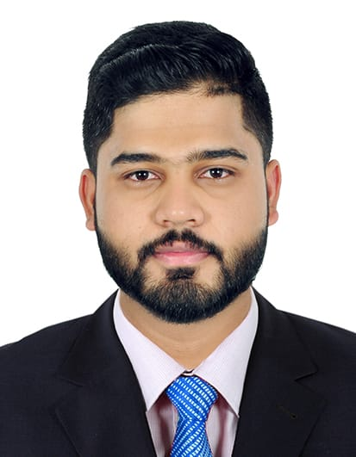
Ronald Radhakrishnan – +973-33992118
Status: Customer Services Coordinator
CAREER OBJECTIVE
Intend to build a career with leading corporate environment with committed & dedicated people, which will help me to explore myself fully and realize my potential. And willing to work as a key player in challenging & creative environment.
PERSONAL PROFILE

Nationality : Indian
Date of Birth : 20/05/1994
Religion : Hindu
Marital Status : Single
Email : ronaldr581@gmail.com
WORK EXPERIENCE

ELITE CAR RENTAL- Bahrain as a Customer Services Co-ordinator from July 2016 till Present.
- Deal directly with customers either by telephone, electronically or face to face.
- Respond promptly to customer inquiries.
- Handle and resolve customer complaints.
- Obtain and evaluate all relevant information to handle product and service inquiries.
- Provide pricing and delivery information.
- Perform customer verifications.
- Set up new customer accounts.
- Process orders, forms, applications and requests.
- Organize workflow to meet customer timeframes.
- Direct requests and unresolved issues to the designated resource.
- Manage customers' accounts.
- Keep records of customer interactions and transactions.
- Record details of inquiries, comments and complaints.
- Record details of actions taken.
- Prepare and distribute customer activity reports.
- Maintain customer databases.
- Manage administration.
- Communicate and coordinate with internal departments.
- Follow up on customer interactions.
- Provide feedback on the efficiency of the customer service process.

NIPPON TOYOTA Pvt Ltd, Kochin - as a Call Centre Executive from December 2014 to June 2016.
- Answer incoming & outgoing calls and respond to customer’s queries, requests & Complaints.
- Management and resolve customer complaints.
- Collect the feedbacks & complaints and register in the computer system to do the follow-up with the respective customer relations team to resolve customer’s complaints.
- Identify and escalate issues to supervisors.
- Provide product and service information to customers.
- Research required information using available resources.
- Research, identify, and resolve customer complaints using applicable software.
- Process orders, forms, and application.
- Route calls to appropriate resources.
- Document all call information according to standard operating procedures.
- Recognize, document, and alert the management team of trends in customer calls.
- Follow up customer calls where necessary.
- Up sell products and services.
- Complete call logs and reports.
- Other duties as assigned.
EDUCATION
- Completed Bachelor Of Computer Application (BCA) – Sree Narayaguru College Coimbatore- Bharathiar University.
- Completed Higher Secondary from Government Higher Secondary School Koduvayur, Palakkad.
- Completed Secondary Education from from Government Higher Secondary School Koduvayur, Palakkad.

COMPUTER KNOWLEDGE

  - MS Office
  - C
  - C++
  - COBOL
  - Visual Basic
  - JAVA
  - Internet
LANGUAGE

 | Read | Write | Speak
English | Yes | Yes | Yes
Hindi | Yes | Yes | Yes
Malayalam | Yes | Yes | Yes
Arabic  Tamil | -  - | - | Yes  Yes

PERSONAL ATTRIBUTES

- Rapid learning ability in all situations.
- Self-confident, motivated and Goal oriented.
- Confident being part of successful, punctual, commitment and reputation.

DECLERATION

I hereby declare that the above mentioned details are true to the best of my knowledge and belief; I will provide all supporting documents in origin on demand.

Ronald Radhakrishnan

