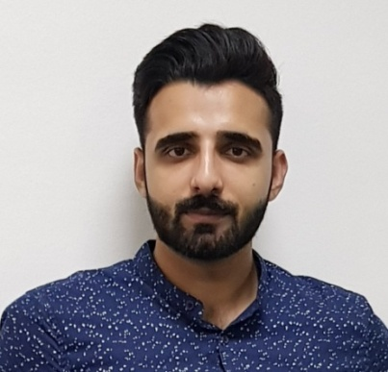 |  | RAEES HAMZA  Junior Finance
Profile  ‘Motivated young professional with an exemplary academic record and passion to progress within the financial industry.’  Having achieved excellent grades at intermediate level Mathematics and English, along with an active involvement in a number of clubs and societies, I am keen to pursue a career in the financial industry. I have a proven aptitude for mathematics and have made a number of notable achievements in both my studies and extra-curricular activities at university level which would make me an excellent asset to any finance or even accounts team or department. My part-time roles and volunteer work have also provided me with a range of workplace skills such as relationship building, communication and team work.  Nationality: Bahraini  PHONE: 973-35088127  EMAIL:raeeshamza142@gmail.com  License: Have valid Bahraini driving license  Hobbies  - Reading business and financial magazines.  - Following business and financial news.  - Organizing events or activities.  - Attending social or business events. |  | ACADEMIC QUALIFICATION  S.S.C (Secondary School Certificate)  (2013) Pakistan School, Bahrain  H.S.S.C (Higher Secondary School Certificate)  (2015) Pakistan School, Bahrain  Bachelors in Banking and Finance  (2021) University of Bahrain  WORK EXPERIENCE  Assistant Accountant at Shahico Services  Reconciled financial discrepancies by collecting and analyzing account information. I know how to use quick books.  Promotional Work at Batelco  November 2018 - February 2019  Conducted research and surveys which helped the company in managerial ways.  Marketing Activities at IPSOS  March 2018 – May 2018  Recommended marketing plans and activities for products and product lines to establish, enhance and distinguish product placement.  Handle Human resources activities at Key Arabia-Talabat  Responsible for recruiting, screening, interviewing and placing talabat riders. Consult with top executives on strategic planning.

