CURRICULAM VITAE

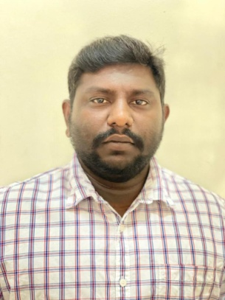

Name: Ebenezer Jayarajan
Phone: +973 37730332
Whats app no. +919943447429
E-Mail: ebenezer.jw@gmail.com

Education

Diploma in Civil Engineering @ Scad polytechnic college (2010)
(Directorate of Technical Board, Government of Tamil Nadu)

Computer Knowledge

- Office: MS Office and Essential software’s with Latest Operating Systems.
- Technical: AutoCAD

Personal Details

- Relationship status : Single
- Father’s name : Jayarajan
- Date of Birth : 22-05-1990
- Nationality : Indian
- Languages known : English, Hindi & Tamil.
- Passport no : M3796454

Objectives

Dedicated and experienced Civil Engineer with extensive knowledge of engineering principles, theories, specifications and standards. Bringing leadership, drive, and over eight years of experience.

Experience

Eight years experience in Civil Construction.

- Site Engineer

- (From 20.10.2018 till present)

- AL MANARTAIN CONTRACTING (Bahrain)

Following inspection as per drawing and specification. Preparation of daily site inspection reports and preservation of all approvals. Preparing monthly evaluation and ordering materials based on requirements. Co-ordination with sub-contractor site staff for delivery of good quality of job. Carryout the material inspection of the company Clearing the doubts in site and give measurements in sites and checking the quality of work according to the drawing specification. Executing project according to schedule .

- Jr.Site Engineer

- (FROM 01.03.2013 TO 30.12.2016)

- SRI SARASWATHI & CO.

Following the inspection as per specifications and drawings. Preparation of daily site inspection reports and preservation of all approvals. preparing monthly evaluation. Carryout the material inspection of the company Clearing the doubts in site and give measurements in sites and checking the quality of work according to the drawing specification. Executing project according to schedule .

- Jr. Site Engineer

- (FROM 05.07.2011 TO 19-11-2012)

- STARLITE ENTERPRISES

Following the inspection as per specifications and drawings. Preparation of daily site inspection reports and preservation of all approvals. preparing monthly evaluation. Carryout the material inspection of the company Clearing the doubts in site and give measurements in sites and checking the quality of work.

- Jr. Site Engineer

- (FROM 1.05.2010 TO 30.04.2011)

- P.K.CUTTING TECH PVT LIMITED.

Following the inspection as per specifications and drawings. Preparation of daily site inspection reports and preservation of all approvals. preparing monthly evaluation. Carryout the material inspection of the company Clearing the doubts in site and give measurements in sites and checking the quality of work.

Declaration

I hereby declare that all the details furnished above are correct to the best of my knowledge.

Ebenezer Jayarajan

