CURRICULUM VITAE
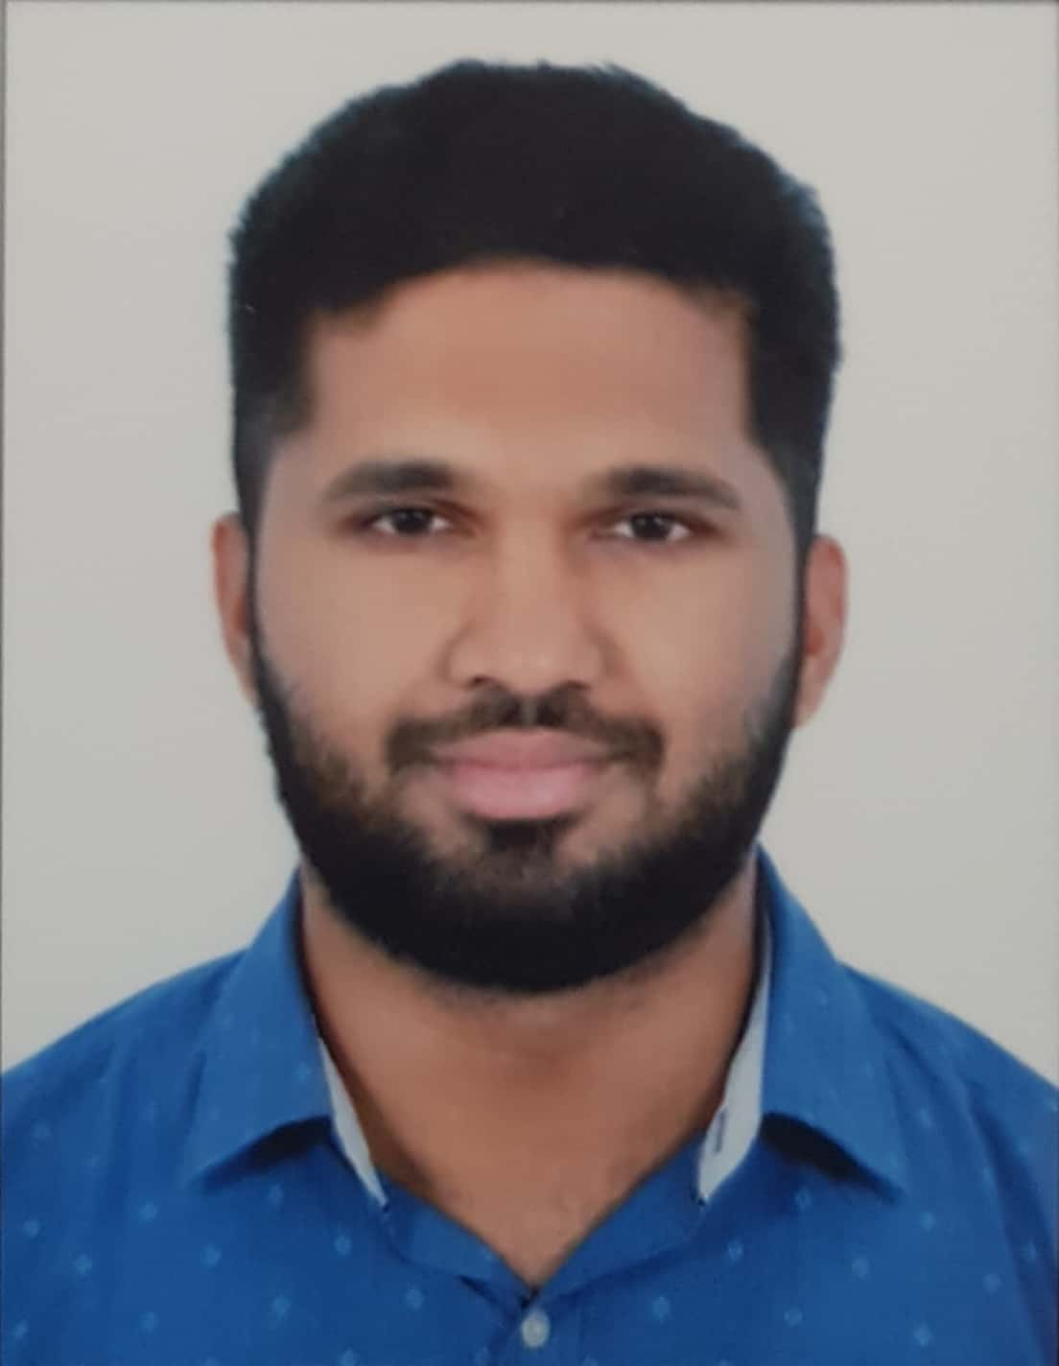
Mohammed Ameen
E-Mail: ameen_779@yahoo.com
Mobile No: +973 3689 8330
Objective:
To be a member of an organization where growth and prospects are unlimited and individual is recognized by my work. As a professional I am creative and innovative, looking forward to strive and excel in a challenging atmosphere
Career Summary:
Have an overall experience of Ten years in Engineering & Supervision with Mechanical Piping, Structure, Maintenance, Plumbing & Drainage, Fire Fighting, Mechanical Infra and HSE in India & Bahrain
Supervised Erection / Installation and Maintenance of the following: Piping, welding, Structural Steel, Plumbing and Drainage, Fire Fighting, Mechanical Infra such as Foul Sewer, Surface Water and Potable Water Networks.
Educational Qualification:
- Bachelor of Engineering in MECHANICAL ENGINEER with First Class from Visvesvaraya Technological University, Belgaum, India in the year 2011.
- Qualified in NEBOSH International General Certificate in the year 2012.
Other Qualification:
- Internal Auditor course for ISO 9001, ISO 14001 and OHSAS 18001.
- Confined space attendant and entry certificates.

Skills:

Software : AutoCAD, MS Office (any version)

OPERATING SYSTEMS: Any Version of Windows.

Professional Experience:
- Currently working in Delta Construction Company, Bahrain for MEP Department taking care of MEP activities from 26th June 2016.
Position : Mechanical Engineer
Projects Handled:
- Devji Jewellery Factory @ BIIP, HIDD
Main Contractor: Delta Construction Co. W.L.L.
- Installation of Drainage & Water Supply Services
- Fire Fighting Works
- Installation of Compressed Air Piping
- Testing & Commissioning
- Devji Aurum Jewellery Factory @ BIIP, HIDD
Main Contractor: Delta Construction Co. W.L.L.
- Installation of Drainage & Water Supply Services
- Fire Fighting Works
- Installation of Utility Services for Jewellery Factory
- Installation of LPG Piping
- Testing & Commissioning
- Deerat Aloyoun Project for Villas & Secondary Infra at Asset 23A-2 at Diyar Al Muharraq
Main Contractor: Cyprus Cybarco Tabet
- Installation of Plumbing & Drainage Services for Type D11 & A1 Villas
- Installation of Foul Sewer, Storm Water & Potable Water piping and Manhole Construction as per SEPPD Standards
- Deerat Aloyoun Project for Villas & Secondary Infra at Asset 22B-1 at Diyar Al Muharraq
Main Contractor: Ahmed Mansoor Al Al-Ali
- Installation of Plumbing & Drainage Services for Type D11 & A1 Villas
- Installation of Foul Sewer, Storm Water & Potable Water piping and Manhole Construction as per SEPPD Standards
- Deerat Aloyoun Project for Villas at Asset 22B-1 at Diyar Al Muharraq
Main Contractor: Ahmed Mansoor Al Al-Ali
- Installation of Plumbing & Drainage Services for Type D11 & A1 Villas

- Plumbing & Drainage Works for Mall of Dilmunia
Main Contractor: Cyprus Cybarco Tabet
- Installation of Drainage & Water Supply Services
- Design of Foul Sewer Manholes as per SEPPD Standards
- Plumbing & Drainage Works for Multipurpose Building & Rotunda Beach Villa at Jiddah Island
Main Contractor: Axion Imagineering
- Installation of Drainage & Water Supply Services
- King Hamad American Mission Hospital @ A’ali
Main Contractor: Smart Skyline Civil Contracting
- Installation of Drainage & Water Supply Services
- Fire Fighting Works

- AAA Al-Rayes Mechanical Contracting Co. W.L.L, Bahrain from December 2012 to May 31 2106.
Position : Project Engineer
Summary of Experience
- Management representative and internal auditor of the organization for Integrated Management System.
- Making AutoCAD sketches & detailing to facilitate execution of structural & piping fabrication for the plant.
- Make estimation for the given drawing from the client.
- Review of Contract Documents and drawings.
- Procurement of materials and other consumables for the project.
- Supervise the Fabrication, welding, hydro testing, pigging, hookup & shutdown works in compliance to drawings.
- Supervise the workers performance and allocate the workers for different sites and coordinate with workers and staff for daily requirements on site.
- Supervise the Material Procurement and collection of Materials from stores.
- Handling of financial matters like invoicing, statement of accounts and maintaining records.
- Preparing salary slip for the workers.
- Project planning and executions.
- Evaluation of progress and monitoring time bound projects to meet targeted schedules.
- Preparing of Method statement, Risk assessment and giving Tool box talk on site.

- Subcontractor to Mangalore Refinery& Petrochemical Limited, Mangalore from August 2011 to September 2012.
Position : Mechanical Engineer

Summary of Experience:
- Inspecting the incoming materials for damages, dimensions and corrosions and ensure that MTC is available and according to the requirements.
- Monitoring step by step the fabrication work-in progress at workshop site and the assembly of the industrial valves along with its auxiliaries as per design, codes and standards.
- Coordinating and liaising effectively with all concerned departments to expedite the work in progress / in hand ensuring timely completion.
- Directing and coordinating the work functions of personnel within department and liaising with other departments to achieve maintenance targets on time.
- Conducting the Hydro tests for the Valves (Body and Seat Tests) according to design, codes and standards.
- Check flow direction arrows on valves; verify that the properly identified valves are installed in accordance with the flow diagram. Ensure that pipe supports hangers and guides have been installed in accordance with the piping drawings and the pipe support details.
- Witness final pressure tests, including verification that pressure gauges have adequate dial range and is calibrated. Verify that the required test pressure was maintained for the specified length of time with no acceptable leakage.
- Preliminary welding inspection activities (fit up, root pass, intermediate, hot pass, material trace ability, dimensional checking and orientation of piping components).
- Monitoring and inspecting the prefabrication works by the sub-contractors including the inspection of incoming materials, material handling, heat number transfer, Fit-up, welding activities.
- Inspecting the painting works done by the subcontractors on the fabricated pipe spools. Make sure the Pipe spools are properly covered with the end caps and safely transported to the site without any damages.
- Monitoring and inspecting the erection works by the subcontractors including piping, welding and insulation and also Co-ordination with client and subcontractors for the quality issues and issuing NCR’s when non-conformity activities were noted by the subcontractors.

Personal Profile:
Date of Birth : 09-07-1989

Gender : Male

Nationality : Indian

Marital Status : Married

Languages : English, Hindi, Kannada, Malayalam & Tulu.

Passport No : S2894862

CPR No : 890726981

CRPEP licensed Engineer

Valid Bahraini Driving License

Future Task: I would like to work in your big organization where I can prove myself for the assigned job.

I hereby declare that the above details are true to the best of my knowledge.

Mohammed Ameen
Place - Kingdom of Bahrain

