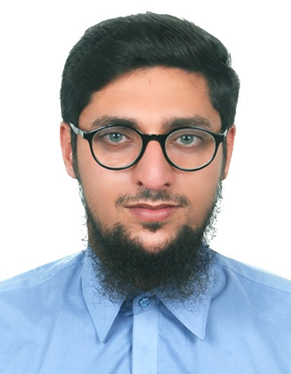
MUZAMAL HUSSAIN
CONTACT #

Mob: 00973-33734001
Muzamalgill398@gmaill.com
Post applied for : Electricial.Supervisor
Work Experience:

- 2year​ experience as a Ele technician in sitara energy Pakistan, 2012 to 2014

- 3year experience as a Electrical foreman in Mercury middle east. Will KINGDOM OF BAHRAIN, 19 December 2014 to 19 December 2017
- 2year ​experience as a electrical foreman in (MAK) Muhammad abdul Mohsen Alkhrafi
kingdom of Bahrain in awali cardiac center Bahrain project January 2017 to2020
3year experience as Electrical Supervisor in (FTCO) Alfozan general trading Co (KAMC) hospital project march 2020 to till now.

Personal Skills:
- Read all type of drawings ifc, shop drawings ,schematics
- Penal board schedule and single line diagrams
- Good knowledge in Pvc, emt and Gi condiutings
- DB dressing and termination work
- Elv sestyam fire alarm, Data, cctv , and Access control Devices installation

Educational Qualification:
- S.S.C _Secondary School Certificate -2009
- (DAE) DIPLOMA OF ASSOCIAT ENGINEER in Electrical Technology 3 year

Personal Information​:
S/O: Asif Ali
CPR: 941123243
Sex: Male
Religion: Islam
Date of Birth: 02/11/1994
Nationality: Pakistan
Marital Status: Single
Language : English ,Hindi
Driving license : valid
Passport Details
Passport No: ET6901661
Date of Issue: 21/08/2018
Date of Expiry: 19/08/2028
Declaration:

​I hereby declare that above mentioned information is true and correct to best of my knowledge and belief.

Date……………………

Signature……………………

