CURRICULUM VITAE

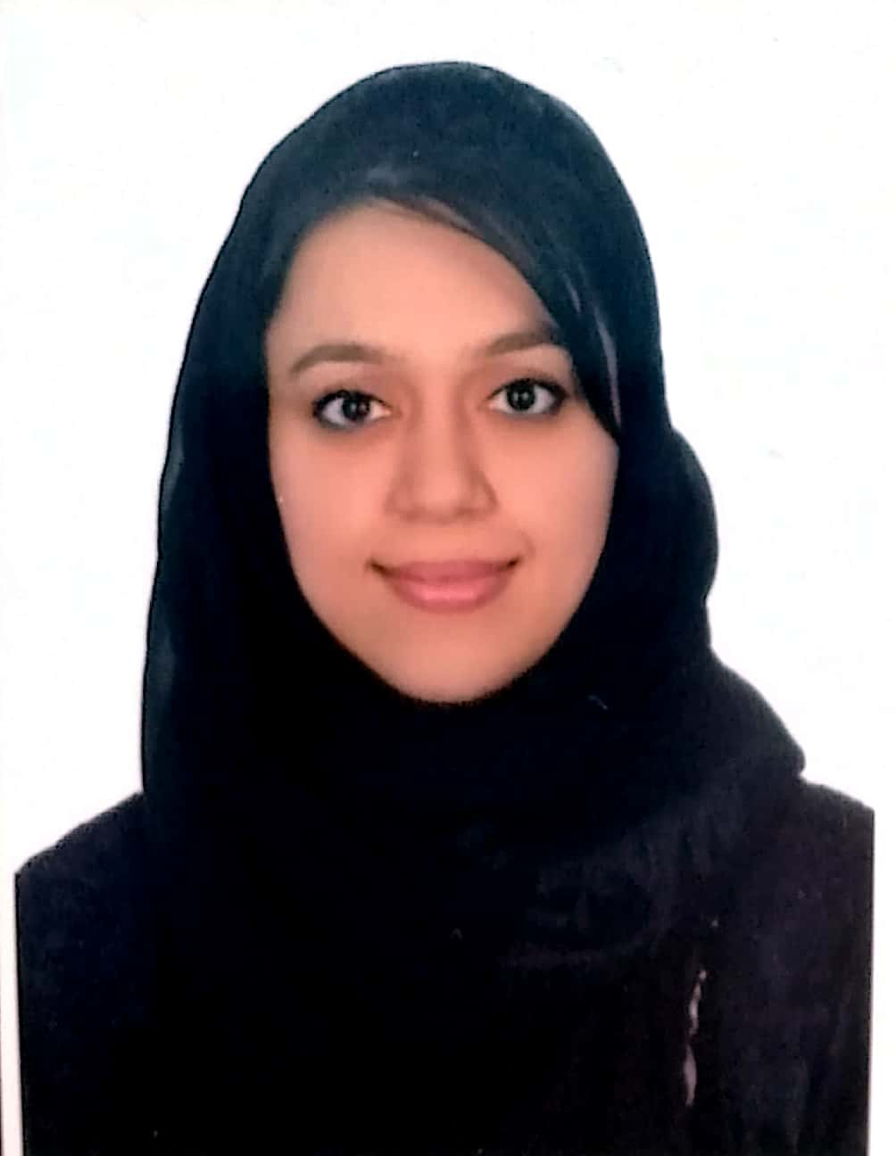
PERSONAL DETAIL
NAME : Zainab Nazir
Father Name : Nazir Ahmed Said Ahmed Mohammed
Sex : Female
Date of Birth : 27/10/1988
Place of Birth : Muharraq, BAHRAIN
Religion : Islam
Nationality : Bahraini (Passport No. 2003981)
Address : Villa 198, Road 5409, Qalali 254, Bahrain.
National ID : 881013609
Contact no. : +97335042077
E-MAIL : znt8827@gmail.com
Licence : Saudi Commission for Health Specialities (Yes)
Bahrain Medical Licence (Yes)

objective:
As a beginner in the field of medical science, with my good interpersonal and communication skills, I will be able to confidently deal with all the level of people working in the organization. I would put all my efforts in research and development of present health care system. I would be devoting my time and extra effort to work for the advancement and progress of the organization.

Education:
- 2004 : PAKISTAN SCHOOL (BAHRAIN)
- S.S.C (Secondary School Certificate)

-2007 : PAKISTAN URDU SCHOOL(BAHRAIN)
- Intermediate in science: (Pre-Med)

-2007-2012 : TIANJIN MEDICAL UNIVERSITY (CHINA)
- BACHELOR OF MEDICINE AND BACHELOR OF SURGERY (MBBS)

-2011 : TIANJIN GENERAL HOSPITAL(CLINICAL ATTACHMENT)
INTERNAL MEDICINE
SURGERY
OPHTHALMOLOGY
ENT
PEDIATRICS
GYNECOLOGY
RADIOLOGY
EMERGENCY DEPARTMENT

-2013 : SALMANIYA MEDICAL COMPLEX
INTERNSHIP

Professional work history:
- Salmaniya Medical Complex (SMC)
- Internship Training Program (1st August 2012 – 31st July 2013)
- Al SENAN MEDICAL CENTER (1st October 2016 – 1st october 2017) Gp and dermatologist assistant

- Al amal hospital (1st November 2017–30th march2019)

- KimsHealth medical center (15th may 2019-present)

Activities
- SPORTS : Like playing basketball, badminton and Cricket.
- SOCIALIZING : Like attending parties and family gatherings, enjoy out with.
- MUSIC : Love listening to music mostly English and Arabic.

Technical Skills:
- Microsoft Office Word
- Microsoft Office Excel
- Microsoft power point

Languages:
- English: High proficiency in reading, writing and speaking
- Urdu: High proficiency in reading, writing and speaking
- Hindi: High proficiency in speaking
- Arabic: Well understood and read.
- Chinese: Can read ,write and speak fluently

References:

Available upon request.

