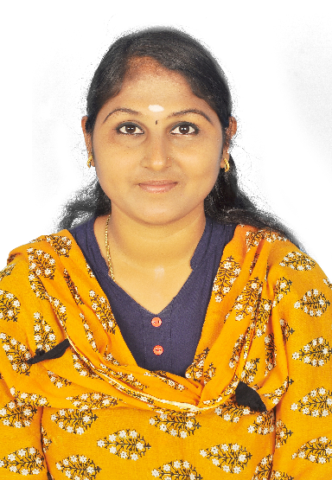 |  | EDUCATION
BAJARANG ENGINEERING COLLEGE, CHENNAI-( Anna University)

2011 - 2014
[COMPLETED BACHELORS OF COMPUTER SCIENCE ENGINEERING.WITH FIRST CLASS CGPA]
M.DURGA  ADMINISTRATIVE  ASSISTANT  PROFILE  Having 6.5 years of experience in Admin related activities. To get a challenging career to utilize my skills and abilities in the field that offers professional growth while being resourceful, innovative and flexible. Over 6.5 years’ experience in Admin, HR Executive & Documentation.  Having experience in interacting with good communication skill. Expertise in handling the Team and supervision the Coordinate office activities and operation to secure efficiency and compliance to company policy Supervise the staff and divide responsibilities to ensure performance Manage Appointments /Arrangements for the upper management.  CONTACT  PHONE:  +973 3542 8952  +91 9659499060(whatsup)  EMAIL:  Dividurga2@gmail.com  magesh@gems-bahrain.com  STRENGTH  - Positive Attitude, self-motivated and Time Management.  - Ability to handle multiple tasks.  - Can effectively communicate with others.  - Adaptability and Quick Learning.  Professional Training  - Implant Training at HCL Company.  - Underwent Industrial Visit at Flowserve.  - Underwent Industrial Visit at Infosys.  - Underwent Android workshop of IIT, Bombay.  DYNAMIC QUALIFICATIONS  - Good communication and management analytical skills  - Able to work Independently  - Proactive with positive learning attitude  CERTIFICATIONS  - KAIZEN.  - 5 S Certified.  - 6 Thinking Hats certified.  SKILLS  - Decision-making: To make independent decisions on a daily basis, addressing the best way to handle specific tasks.  - Communications and collaboration: Must collaborate with other administrators and support personnel, management and clients on a regular basis.  - Organizational skills: Organization and prioritization are the core elements. To keep myself and others organized and how to determine which tasks are the most important in a given list.  - Writing: Spelling, punctuation, sentence structure and writing are essential to me I will be proficient in a variety of styles, from creative to professional to technical to education and more.  About Me  - I am Responsible for running and coordinating the day-to-day administrative duties of an organization.  - MY communication skills and the capacity to manage several tasks or requests simultaneously.  - MY Soft skills such as being professional and exceptional with time management are also valuable to include.  CONTACT DETAILS  - Date of Birth : 02.04.1992  - MOBILE : +918754711246  - AGE / SEX : 28 / Female  - LANGUAGES KNOWN: English, Tamil, Telugu  - NATIONALITY : Indian  - RELIGION : Hindu  - ADDRESS: NO 157,BIG STREET  PARAMESHWARAMANGALAM  Arakkonam Taulk  Ranipet Dist |  | WORK EXPERIENCE
POWER CENTER INDIA PVT LTD (ADMIN & HR ASSITANT)
Mar 2018–March 2020
- Coordinate office activities and operation to secure efficiency and compliance to company policy.
- Supervise the staff and divide responsibilities to ensure performance.
- Manage Appointments /Arrangements for the upper management.
- Manage phone calls, mails etc.
- Create and update record & database with personal and other data.
- Track stock of office supplies and pace order necessary.
- Submit timely report and prepare presentations assigned.
- Assist colleagues whenever necessary.
- End-to-End Customer Lifecycle Management.
- Being a point of contact for a range of staff and external stakeholders.
- Write and edit documents from letters to reports and instructional documents
- Create and maintain filing systems, both electronic and physical
- Schedule and coordinate staff and other meetings
- Bringing Intelligence to sales.
- Identifying & developing complex high value business opportunities.
- Maintaining all Quality parameters critical on licensing.
- Managing Business Margins.
- Business Forecasting and Planning.
- Quarterly and Yearly business reviews, Evaluation and Synthesis.
- Synchronization of Cross Functional teams and other diverse business entities to accomplish overall business goals.
- Planned execution at all level

ANI TECHNOLOGIES, SAIDAPET, CHENNAI (ADMIN ASSITANT)
Oct 2016–Feb 2018
- Answering and directing phone calls to relevant staff
- Scheduling meetings and appointments.
- Taking notes and minutes in meetings.
- Ordering and taking stock of office supplies.
- Being a point of contact for a range of staff and external stakeholders.
- Preparing documents for meetings and business trips.
- Processing and directing mail and incoming packages or deliveries.
- Greeting and directing visitors and new staff to the organization handling a variety of tasks in order to ensure that all interactions between the organization and others are positive and productive.
- Anticipate the needs of others in order to ensure their seamless and positive experience.
- Writing and issuing emails to teams and departments on behalf of teams or senior staff.
- Researching and booking travel arrangements for staff members.
- Finding ways to improve administrative processes.

LARSEN & TOUBRO (L&T)
ADMIN EXECTIVUE
Aug 2014–Aug 2016
- Assume the role as the primary point of contact between the executives and internal/external clients Assume the role as the primary point of contact between the executives and internal/external clients
- Maintain a daily electronic journal, arrange meetings and appointments and provide reminders as needed; maintain a master corporate calendar of all conferences, all-hands events, holidays, and vacations
- Handle requests, feedback, and queries quickly and professionally
- Arrange executive travel, hotel and dining arrangements as needed
- Take dictation and meeting minutes, accurately enter notes and distribute
- Monitor office supply levels; reorder when appropriate
- Maintain strong relationships with vendors and keep price data in order to get the best pricing on supplies and services
- Produce professional-quality reports, presentations and briefs
- Develop and carry out an efficient documentation and filing system for both paper and electronic records
- Delegate tasks as appropriate to other members of the team

Clients Handled:
CPCL, SPIC, IOCL, SAIL, NLC, ONGC, Reliance, Petrofac, FMC, Shell, Total etc.
 |  | DECLARTION
I hereby declare that all the details mentioned above are in accordance with the truth and fact as per my knowledge and I hold the responsibility for the correctness of the above-mentioned particulars.

PLACE:
DATE:

