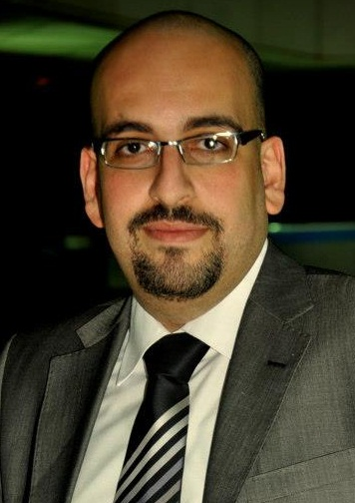
Mohamed Mohamed Zaki Al-Zahar
Mohamed_elzahar@hotmail.com
+973 33212932

Career objective
A challenging and rewarding position with a Company that fully utilizes and further strengthens my Educational, interpersonal, communication and leadership skills...
Educational background
- Bachelor of Management Information System
- Grade: Good
- Graduation Project Grade: Very Good
Experience
- From September 2006 till November 2007
Worked as Sales supervisor at “Dot Egypt Group (Egyptian Company for Internet services and networks)"

- Responsible for increase the proportion of TE Data distribution and continuously train company’s staff on regular basis.
- In addition, they open new channels of communication in a number of provinces and cities & Train the team to implement the new changes.

- From December 2007 till February 2010
Worked as Manager of networking and computer maintenance Department at “Aspire Investment Company (for Marketing and Financial Consulting)"
- Responsible for monitoring, training and reviewing overall performance of all the company's existing hardware and staff training on the new programs and how to deal with and resolve technical problems. (Experience certificate available)

- From April 2010 till May 2013

Working as Trainer /project coordinator at "Smart Vision"
- Train & Coordinate the new joiners, Responsible about departments development/ Training , and manage the information technology to find the best ways to train to a high standard as possible

- From October 2013 till November 2015

- Working as HR Trainer / Health & Safety at "Ansar Group in UAE, Bahrain, Qatar"
- Coordinate with Civil defense to conduct evacuation for the mall
- Evaluation of staffs during the training period as well as after training
- Certifying the capability of the trainee after the training period as well as after training
- Providing the reports for training for HR, PRO and management for approval of visa
- Coordination with other departments, if needed for further training
- Monitoring the performance of staffs on the floor and to provide help if needed and provide information to all queries of staffs related to company and its policies.
- To help in minimizing pressure and stress by providing suggestions to employees regarding workload
- To provide solutions with regard to the staffs De-motivational aspects in regards to work, company or management.
- To discuss about the staffs activities with the management for any improvements needed for business growth and to take alternative steps according to the management decisions.
- Scheduled visits and discussions with all staffs related to work. (Managers, Supervisors, etc.)

- From December 2015 up to now

Worked as senior manager business development at Origin Consulting Group (Bahrain – Oman – Saudi Arabia – UAE)
- Study agreements and agree on common points of cooperation between the company and partners.
- Business development and work to attract more investments and to provide advice to management.
- Find new partners in business in all over the world.
- Handling all the sales & marketing.
- Full responsibility about Exhibition management.
- Opening the new office in Sultanate of Oman

- Working as a safety officer at Origin Training Center
- Responsible for all safety issues and coordinate with Civil defense for safety issues
- Conduct training for OTC staff in safety / Basic skills
- Coordinate with Medic to train some staff in Frist Aid & CPR
- Conduct indication for the new joiners / all the trainees at the beginning of any course
- Other Experience:
- Working as free-lance in Forex marketing & Training
- Working as a safety consultant
- Working as freelance in Real Estate Investment.
- Working as free lance in Tourist cities equipment
- Work in Organizing exhibitions and concerts
(Freelance)

Professional skills

Language skills
- Native language Arabic " Mother Tongue "
- Good command to both written and spoken English

Computer skills
- Professional in Computer Maintenance Software and Hard ware
- Good knowledge of Word, Excel, Power point, Access, Internet and Presentation skills
- Microsoft operating system (XP, Vista and windows 7)
- Hardware Mother Board and Hard Disk
- Simple experience in video structures Maker and Swish Max
- Establishment of input Corporate networks
- Working on Photoshop Program

Certificates
- A certificate of training of trainers (TOT) From Ansar Group (Dubai)
- A certificate of Leadership Development From Leadership Development Institute (Helwan)
- A qualified health and safety in the workplace (NEBOSH) Level II. international certificate (London)
- First-Aid& CPR international license for two years from the Medic Institute (USA)
- The 7 habits of highly effective people (Franklin Covey)
- The Power Within II - Creativity At Work - By Tony Buzan
- Member in ITOL for training and development UK
- A certificate of train the trainers (TOT) Ta’sel - Bahrain

Other skills
- Active listening: giving full attention to what other people are saying.
Speaking talking: to other to convey information effectively.
- Critical thinking: using logic and reasoning to identify the strengths and weaknesses of alternative solutions, conclusions or approaches to problems.
- Persuading: the public, investors, partners, employees, and other stakeholders to maintain a certain point of view.
______________________________________________
Hobbies
- Logging and search onto internet
- Reading and Learning
- Helping others

Personal data
Date of birth : 18th of July 1984
Marital status : Single
Military status : Exempted
Nationality : Egyptian
Residence : Bahrain
CPR NO : 840757930

