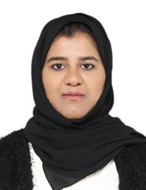
Nadia Karamat Ali
Mobile: +973-35082900
Email: nadiaa.mudassar@gmail.com
Nationality: Bahraini

Career Objective:
I am willing to do my level best to prove myself as talented and hardworking. I would give my best as a team member of any team that I am assigned to work in.

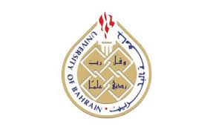
Education:

- BSC in Business Management Feb 2010 – June 2017 University of Bahrain

Courses taken:

- Introduction to Business Management
- Organization and Management
- Marketing Management
- Organizational Behavior
- Production Management
- Managing Small Businesses
- Organization Development and Change
- Intermediate Marketing
- Human Resources and Personnel Management
- Creativity and Innovation
- Knowledge Management
- Managerial Economics
- Database Management Systems
- Operations Research
- Financial Management
- Financial Accounting
- Cost Accounting
- Personal Selling


- Higher Secondary School Certificate 2004 - 2006 Pakistan Urdu School

Work Experience:

- 3 months’ probation as a Receptionists at Berlitz Bahrain (01-October 2017 to 31-December-2017)
- Business Management Intern at Al Qoud Consultancy ( 01 March 2017 to 30 April 2017)

- Personnel Clerk at Pakistan Urdu School (01-Oct -2007- 31-Oct 2008)

Job Responsibilities

- Preparing Ministry Approval forms of the staff members
- Preparing Labor forms of the staff members
- Preparing monthly salaries of the staff members
- Short hand typing
- Filing
- Photocopy, scanning and printing.

Personal Details:

Date of Birth: 31st-March-1988
Place of Birth: Bahrain
License: Holding valid driving license
CPR number: 880310146

Languages:

English: Excellent spoken and written.
Arabic: Want to improve

Professional skills:

- Recognizes and respects different perspectives. Open to the ideas and views of others
- Cultural sensitivity
- Excellent Teamwork qualities
- Excellent work ethics and coordination with people
- Ability to prioritize and organize work related activities.
- Computer skills (Microsoft Office)
- Effective communication skill
- Persistent
- Able to express myself clearly in writing.
- Able to motivate and direct others.
- Continues to learn throughout life. Develops the competencies needed for current and future role

