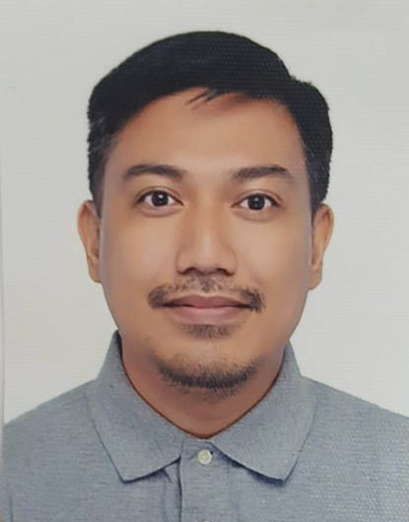
Arnel Merlin Roderos

Flat 23 Bldg.3444, Road 1859

Block 318, Al Hoora Manama
roderos.arnel@gmail.com

+973-36330165

objective:

Seeking a sales position with a reparable company on a long-term basis who is looking for an experienced, hardworking, detail-oriented team player.

Professional Experience

Fathom Media. — Road 3281, Block 328, Adliya, Bahrain
Team Director, 2020
We construct and refine clients vision and identities. We provide meaningful content and impactful campaigns and strategies. As a team director I focus on providing User Experience and User interface designs until developing applications for clients to use.

Graphic Artist, 2019
We conceptualize, produce designs and media projects. We generate ideas and make them happen.

MegamobIle Inc. — Makati City, Metro Manila
Head of VAS/NOC - Technical Operations and Business Development, 2011 – 2018
Key Responsibilities:
- Supports the business development requirements of the company through understanding customer needs, responsive and supportive as deemed required;
- Conducts quality assurance and user acceptance tests on the mobile services to be launched by the company;
- Ensure network access that complies with the leading standards;
- Performs applications development, web and/or mobile, as required by the company;
- Design, develops, implement, configure, document, administer, monitor and maintain components of the mobile and/or web infrastructure and applications as may be assigned by the operations manager;
- Performs from time to time, interfaces with mobile network partners and clients;
- Ensure periodic backups of database and network components configuration.
- Mobile service developments;
- Support colleagues and IT functions to fulfill project goals maintain business continuity.
Database Administrator: responsible for development, production and multiple testing environments. Provide, evaluate and develop data access tools and techniques. Build script automating the daily operations of database managements.
Systems Administrator: responsible for network infrastructure, systems and server administration and maintenance. Ensuring the network integrity and security. Troubleshoot and resolves applications performance issues. Conduct application transaction volume and traffic analysis and interprets its impact on systems performance.
- SQL | - PHP | - HTML
- Apache | - Java | - LAN/WLAN/WAN
Value Added Services and Network Operations Center Management: responsible for system integration between major telecoms in the Philippines.
- Globe Telecoms | - Smart Communications | - Sun Cellular
Mobile SMS Application Programmer - responsible for SMS applications and integration of Mobile and Web applications. Monitor performance against SLAs.
Mobile and Web Applications Developer - responsible for Mobile and Web development. Integrations of Mobile and Website across multiple platforms.
SMS Systems applications - responsible for SMS (short messaging service) for mobile phones and integrating the messages to the network systems to enable users to access website facilities.

SYKES philippines. — Mandaluyong City, Metro Manila
Sales Customer Service Agent, 2011
- Provide professional and efficient customer support to clients of an Internet-based travel website company. Transactions include airline ticketing, hotel reservations and booking, car rentals, cruises and vacation packages.

Customer Service Agent, 2010
- Responsible in receiving and responding to problems, queries and requests from customers by providing satisfying solutions to customers concerns.

IT Customer Care Representative, 2010
- Provide efficient technical support to of the leading internet provider in the U.S. Functions includes Technical troubleshooting, providing assistance to internet connection problems and resolve technical issues experienced by customers.

Education

Systems Technology Institute — Quezon City, Metro Manila
Bachelor of Science in Information Technology, 2011

TechnologICAL Institute of the philippines — Quezon City, Metro Manila
Bachelor of Science in Electronics and Communications Engineering, 2007

personal information
Date of birth: January 11, 1982
Status: Married
Nationality: Filipino
Height: 5’7”

character reference
Available upon request.

I hereby certify that the above information is true and correct to the best of my knowledge and understanding.

Arnel M. Roderos

