CURRICULUM VITAE

Personal Details. .

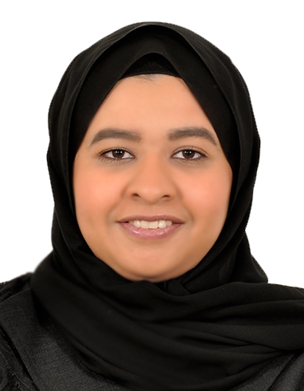

Name: Zainab Ali Kadhem Yousif

Date of Birth: 31st May 1992

Nationality: Bahraini

Telephone No.: +973 34158885 or +973 39204433

Email: ZainabAli.K92@gmail.com

Occupational Goals. .

- Seeking a position in business fields which will enhances my career and improves my skills in management and accounting. Positions sought are Accountant, Internal and External auditor, financial consultant, financial controller and other positions related to accounting and finance.

Educational Qualifications. .

Association of Chartered Certified Accountants Candidate Present

BSc. In Accounting GPA: 3.71 University of Bahrain (2010 – 2014)

Diploma in The Art of Public Speaking & The Power of Influence (2014)

Diploma in NLP (2013)

Secondary School Certificate (96.8 % ) AlHidd Secondary Girls School (2007 – 2010)

Achievments. .
- Graduate of the Elite National Recruitment Program.
- Second class honors degree in Accounting (B.A).

Career Experiences. .
Accounts Manager Bahrain Dutch Foundations June 2016 to Present
- Managing Customer and Suppliers correspondences.
- Managing the Accounting system Tally ERP and entering day-to-day transactions.
- Application of “Value Added Tax” system.
- Managing company accounts with banks, Govermental entities, Tamkeen, insurance and telecommunication companies.
- Executing Annual Audits.

Accountant Assisstant Mgt Development Center Feb 2015 to April 2016
- Follow up with debt collection.
- Preforme all accounting related tasks.
- Market for and sell the instituotions’ programs.

Temporary Replacement M.H. AlMahroos Company Nov 2014 to Dec 2014
Through the Aacpac sofware;
- Prepare Daily Sales Report.
- Reconcile of Bank Statements.
- Prepare reciepts for different methods of paymens.
- Enter the required bank entries.

Intership program BDO-Jawad Habib July 2014 to Sept 2014
Excecuting the entire audit circle for clients;
- Prepare preliminary and final financial statements.
- Performe different tests on financial statement items.
- Connect the resulted evidence to the audit opinion.
- Performe overall casting test.

Additional Personnel Skills . .

- Accounting software skills (e.g. Aacpac and Tally ERP).
- Volunteer with the local charities.
- Strong bilingual writing skills.
- Fluent in English and Arabic and basics in Germany.
- Microsoft office skills: Word, PowerPoint, excel, access and Keyboard skills.
- Ability and desirability to learn more and quick as well as sharing experience.

References. .

Available upon request.

