

Summary
To secure a challenging position in a reputable organizationwhich will benefit from my strong deductive reasoning, mathematical,Administrativeand problem-solving skills.

Skill Highlights
- Accounts management  - Strong decision maker  - Complex problem solver | - MS Office  - Innovative  - Detail oriented

Experience
Accounts Assistant–June 2019- Present
Quality Wire Products Co. W.L.L
- Detailed oriented and diligent with the ability to multitask effectively.
- Maintain standards of quality as established by management
- Filing and maintaining vendor files
- Account statement reconciliation
- Account research, including research discrepancies and cost effectiveness of vendors
- Strong computer skills with a proficiency in data entry.

Education
Al Hoora Secondary School:
Higher Secondary (Vocational).
Human Performance Improvement: International Computer Skills Certification.

References
Upon Request
Nimra
Azeem
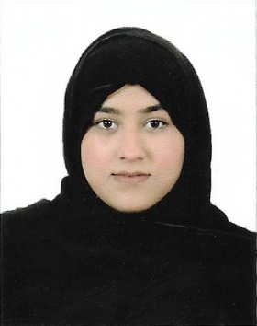

Contact
Phone:
+973-39079466

Email:
nimraazeem974@gmail.com

Languages
English
Arabic
Urdu

Hobbies
- Reading
- Cooking
- Travelling

Personal Data
CPR: 990506134
Date of Birth:21/05/1999
Marital Status: Single
Nationality: Bahraini
Driving License: Valid

