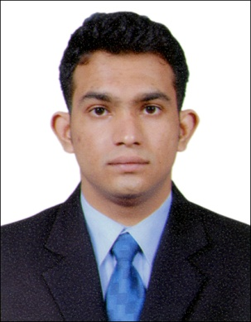ROHAN KAKODKER
Email id: rohankakodker@gmail.com
Contact No.: +91 7378821455
Address: Fatorda Margao Goa India 403602.

Career Objective:
Seeking a deserving profile in your esteemed establishment, where I can deliver my expertise and innovative hospitality skills, while maintaining the integrity and work ethics of the working environment, thereby maintaining the reputation of the organisation.
Professional Profile:
*Company Name: Travel Food Services
*Location: Goa International Airport (GOI)
*Position: Team Leader.

*Company Name: Costa Cruises
*Location: Asia, South America & Europe
*Position: Crew.

*Company Name: Buena Vista Food W.L.L.
*Location: Kingdom of Bahrain
*Position: Crew.

Additional Training:
*AVSEC Training by Central Vigilance Commission.
*Sanitation Programme (USPHS-HACCP) By CAI College Hyderabad.
*All Courses as per IMO-STCW 2010 from NUSI Maritime Academy.

Education:
College:Institute of Hotel Management
Alto-Porvorim Goa.
Smt.Parvatibai Chowgule College of Science & Arts
Margao-Goa.
School:M&N English High School
Margao-Goa.

Additional Information:
*Indos No:15ZL6780. *Indian CDC:Yes.
*Age:28. *Marital Status:Not Married.
*Driving Licence:Yes.

