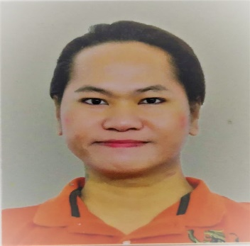
MIKE SANDINO A. SOMIDO

Flat 1 Bldg 366 Road 388 Block 301 Manama

Profmikesomido @ gmail.com
Mobile no. (359-612-80)

Objective: To gain employment with a company or institution that offers me a consistently positive atmosphere to learn new ideas/technologies and implement them for the betterment of the business.

Working Experience:
CAKE BOUTIQUE (Bahrain)
April 3, 2016 – November 8, 2020
Customer Service Associate
It was my fully duty to interact with Customers to provide information in response to inquiries about products or services and to handle and resolve customer’s complaints.
Confer with Customers by telephone/WhatsApp/email or in person to provide information about products and services, to take or enter products.
Also preparing Sales Reports, petty cash, inventory and bank deposit.

SANA Fashion (Bahrain)
January 29, 2015 – March 25, 2016
Worked as a full time retail Sales Associate, I assist customers in choosing the right product, keep the shelves stocked and ring up sales, among many other duties.

Collective Solution International (formerly CA Telemarketing Inc.) (Quezon City)
September 12, 2007 – Feb, 2012
Worked as a Tele specialist, provides outstanding customer service and performs well to achieve goals. Handled Outbound campaigns like FTI, Diagnostic Lab, Diaglabs X-ray, Menus and 3E.
March, 2012 – December 14, 2014
A proud member of Quality Assurance Department. As a Quality Assurance Analyst, I am duly assigned to ensure that all quality aspects are met. I’m evaluating Agents calls and give proper feedback.

Influent Philippines Inc. (Ortigas)
December 15, 2005 to August 17, 2007
As a Customer Contact Associate, I Interact with customer’s over the phone to provide information and provides excellent customer service. Designated to different campaigns/accounts in Outbound Dept. Handled HSBC programs like Identity Protection Plan (IPP), Buyers Edge. Credit Card Acquisition such as GM Flexible Earning Card and CORE. It is also my responsibility to meet the expected goal for each accounts.

Personal Information:
Date of Birth: September 17, 1984
Place of Birth: Quezon City
Nationality: Filipino
Weight: 120 lbs.
Height: 5’5 ft.
Civil Status: Single

Educational Background:
University of the East (Manila)
Bachelor of Science in Information Technology
2001 – 2005

Ramon Magsaysay (Cubao) High School
Secondary Level
1997 - 2001

San Vicente Elementary School
Primary Level
1991 - 1997

Special Skills:
Proficient in Microsoft Office (MS Word, Excel, PowerPoint, Access)
Internet Applications
Customer Service (Sales)

References:
Adrian Santiago
Cake Boutique Manager
(973 667-145-55

Adel Luisa Tira Tira
Cake Boutique Supervisor
(973 ) 387-480-55

