




SOCIAL LINKS

EDUCATION

1999
GNVQ, Advanced IT and Networking Systems(UK)

1988-1992
Bsc(hons) Applied Sciences & Engineering
(Wolverhampton University,UK)

1983-1987
GCSE O levels(8 passed) and A Levels in Physics and Maths
Barking Abbey Comprehensive school, UK

12 Years Business Development- Connected 50+Voice Carriers to Exchange

3 Years Channel Partners- Strategic partnerships with Microsoft, Cisco & IBM

3 Years Business Process Deployment- Optimised E2E Process with QC

3 Years Global Service Training –SSM enabled on Sales Process and Portfolio

1 Year Management– Leadership of IP Solutions Team to increase IP Sales

5 Years Mobile Devices -Drive Digital evolution in Education and Public sectors

3 Years Project Management- Legacy Business and System migration to ERP

TANVIR AHMAD
TELECOMS SALES PROFESSIONAL

A Cisco certified Telecoms Professional with over 20 yrs success in driving Digital Transformation and Business Growth for Global Carriers such as Level 3 and Nokia Networks. A Network Solutions Expert in Mobile and Optical networks who showed Leadership to manage a diverse Solutions Sales team in a matrix organization and increase IP market share across MEA by 10%.A Versatile person who also managed Business Quality Programs by coaching cross-functional teams in Service Sales and Projects to help harmonise the E2E Process and MoO - improving Delivery and Cash generation timeframes by 15%. My focus in recent years has been on delivering Mobile Device solutions to drive Digital Innovation within the Education and Public sectors. A customer centric individual who believes in creating Value to enhance the customer experience. Seeking a new challenge to deliver Innovative ICT Solutions and AI Technologies that can lead us to a fully digitized Business Landscape.
PROFESSIONAL SUMMARY

2013-2014 INDEPENDENT TELECOMS CONSULTANT
Digital Transformation | Bahrain |

- Business Consultancy enabled Technology vendors in Middle East on Market Trends and Emerging Technologies relating to Digital Transformation
- Business Plan, Strategy and Market Analysis documentation drafted to provide competitive edge and increase market exposure


PROFESSIONAL EXPERIENCE
CAREER ACHIEVEMENTS
2015- Present BUSINESS MANAGER, MEA
Cetrix Technologies | Bahrain |

- Strategic partnerships with Global Distributors to promote Customized Tablet Devices and boost business mobility in Education, Energy and Public sectors.
- Sales Drive and Market analysis helped increase market share for Mobile Devices in Education by 2%
- Secured a £150k deal under LIFE Framework Project to modernise the legacy ICT infrastructure at Sydenham School, London

COMMUNICATION
TEAM PLAYER
PRESENTATION
LEADERSHIP
PROBLEM SOLVING
ANALYTICAL
CUSTOMER SERVICE
CREATIVITY

PERSONAL SKILLS

 tanvir19701
 https://web.facebook.com/tanv1rahmad
https://bh.linkedin.com/in/tanvir-ahmad
+973 36045589
t-ahmad@live.co.uk
Amwaj Islands, Bahrain
London, UK(hometown)

CONTACT






HOBBIES & INTERESTS

LANGUAGES

ENGLISH

HINDI/URDU

ARABIC
TECHNICAL SKILLS

CISCO NETWORKING
PROJECT MGMNT
SALES TOOLS(ERP)
IT & MS OFFICE
MANAGEMENT
ICT & NETWORKS
BUSINESS COACHING
TECHNICAL WRITING

Tennis Football Astronomy Travel Dine Out
t-ahmad@live.co.uk
Amwaj Islands, Bahrain
London, UK(hometown)

- Cisco Sales Expert(646-203)
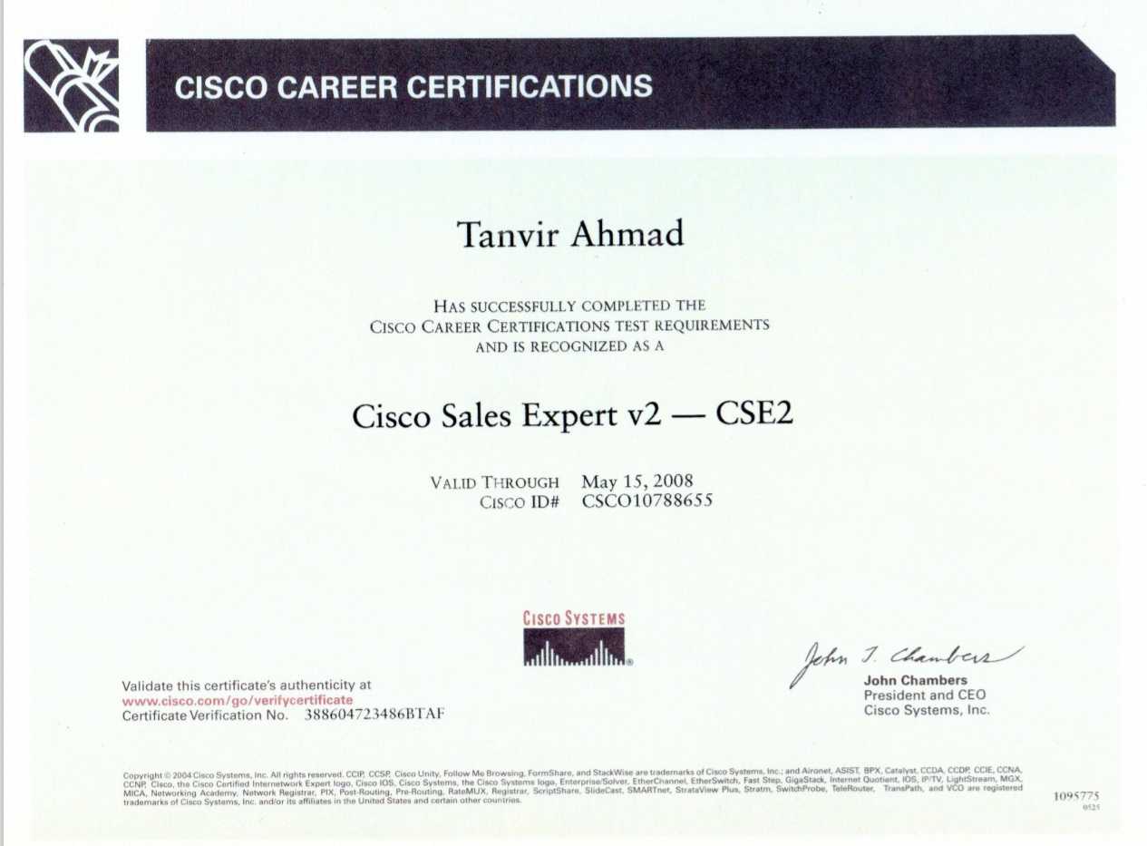

- IBM Sales Academy Training
- Stepping Stone Workshop Series
  - Organisational Change
  - Business Strategy
  - Performance Management
- Business Ethics and Quality
- 7 Habits of Highly Successful People
- Nokia Competence Portal
(Leadership, IP Transformation,
Project Management)

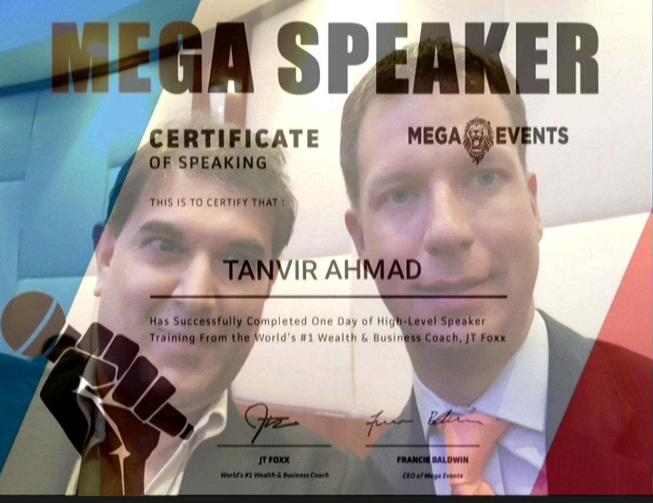

- Public Speaking

TECHNICAL COURSES

1.Sabrina Ronchi(ex manager) Program Manager, Nokia Networks
Sabrina.ronchi@nsn.com +393487126117
2.Nadeem Khalid(personal) IT Business Director,Sysprove
nadeem@sysprove.com +97339609876(mob)

REFERENCES
2000-2006 BUSINESS DEVELOPMENT MANAGER,Service Providers
Level 3(Global Crossing)| London|

- Supported Company Merger activities and increased revenue by £500k
across 25 Global Accounts

- Bespoke Solutions based on SDH, DWDM, Ethernet helped Global Carriers migrate from legacy to IP networks
- Drive business within key accounts to achieve £2m/annum over a 5 year
period with 50 + new customers acquired.
- Part of a Top performing Carrier Team in 2002 that exceeded Annual Target
of £26m and helped company growth from a start up Carrier to become
cash flow positive in 2006
- Major Backbone network upgrade boosted Ford operations in UK(~ £1m)
- Launched the strategic ADSL 2+ Broadband Service (24Mb/s) for Orange
in UK with a £240k access network

1996-1999 RESIDENTIAL SALES ADVISOR
Virgin Media(Cable and Wireless) | London |

- Helped CWC gain a 25% share of the Consumer market for Telco, Cable
and Broadband services from SKY & BT

2007 BUSINESS MANAGER, Global Hosting Services
Verizon(Terremark) | London |

Secured Enterprise partners( Channel, Media, Web 2.0 etc) to help Verizon gain market entry in UK for Cloud Services

Drive Cloud based Virtualization and Data Centre solutions in UK via partners like IBM and VMware to promote SaaS

2008-2009 SOLUTION SALES TEAM LEADER, IP Transmission, MEA
Nokia Networks | Riyadh |

- Developed Sales and Technical skills within a Global SSM Team to upgrade/migrate legacy networks to IP. Highlights include Microwave 3G Expansion deals with STC Mobile(€4.3m)and Mobily(€1.2m).
- Partner collaboration with Cisco and Juniper to help launch our IP Ethernet and Backhaul product within 6mths.
- Generated 15% increase in Wireless Sales by promoting Microwave backhaul in Transport projects(€24m/quarter)

2010 STRATEGIC PROJECTS MANAGER, MEA
Nokia Networks | Bahrain |

- Business Consultancy for Zain Group(Bharti) to support their Network Transformation from 3G-4G
- Software Sales Drive (€6m upsell for SWS/SWM helped with SaaS)
- Coaching to enhance IP/DWDM skills of Solution Sales Team.

2010-2013 BUSINESS DEPLOYMENT MANAGER, MEA
Nokia Networks | Bahrain |

- Migration of Legacy IT Systems improved Data Integrity and MoO in over 50 countries in MEA
- Manage cross functional teams(Sales, Logistics, PM & FC) to enhance MoO through Workshop Training on E2E Process and Sales Tools(CRM)- Reduced cash collection times by 15%
- Business Ethics Training helped achieve Quality compliance
- Implemented Project plans to reduce Delivery timeframes by 10%.
- Training for Services Sales Teams on Global Portfolio and Pricing Tools helped them offer Integrated/Customised solutions

PROFESSIONAL EXPERIENCE

